A453 : Programming project

Controlled Assessment Material 2

By: Manav Parikh

Candidate No. – 1186

Table of Contents

Hardware 4

Software 4

Task 1 5

Introduction to the task and success criteria 5

Research of the task 5

Knowledge needed in Python (crossed out = can do already): 5

For Loop: 6

Random number generation and random operator generation: 6

Data dictionary 7

Algorithm 8

Version 1 9

Code: 9

Test plan: 9

Version 2 10

Research needed: 10

Code: 12

Test plan: 12

Version 3 12

Algorithm V2: 13

Code: 14

Test plan: 14

Version 4 15

Research needed: 15

Code: 16

Test plan: 16

Evaluation 19

Task 2 20

Introduction to the task and success criteria 20

Research of the task 20

Knowledge needed in Python: 20

Assigning data to a file: 21

Writing data to a file: 23

Data dictionary (continued from task 1) 24

Algorithm 25

Version 1 26

Code 26

Test plan 26

Version 2 28

Code 28

Test plan 28

Test plan (fixed) 30

Evaluation 33

Task 3 34

Introduction to the task and success criteria 34

Research of the task 34

Knowledge needed in Python (crossed out = can do already): 34

Methods of storing data: 34

CSV 38

Sorting data 40

Algorithm 42

Version 1 44

Data dictionary 44

Code 45

Test plan 45

Version 2 46

Data dictionary 46

Teacher Testing 48

Teacher Code 53

Student Testing 54

Student Code 60

Student Code (V2) 62

Overall Evaluation 63

Research 64

Algorithm 65

Version 1 67

Version 2 67

# Hardware

* Logitech B100 Mouse
* Logitech K120
* CTX Monitor
* Intel Core 2 Duo vPro CPU
* 2GB of RAM

# Software

* Microsoft Word 2010 – A word Processor which is part of Microsoft Office.
* Python 3.3.2 – A programming language which was required by some tasks.
* Google Chrome – A very good web browser.
* [Hosted software] Gliffy – Used to create flowcharts.
* Windows 7 Professional 32-bit Service pack 1 – The OS I used.
* Camstudio – Used to record videos.
* Adobe Reader XI – used to view the .pdf file which contained the tasks.
* Snipping tool – Used to take screenshots of a specify area of the screen.

# Task 1

## Introduction to the task and success criteria

This task needs me to analyse the requirements in detail and design, code, test and evaluate a program which meets the following requirements.

It should be able to:

* Create two (integer) variables
* Create a function to generate random operators (+, -, *)
* ask the student’s name
* generate 10 random questions which are suitable for primary school children
* verify if the answers the student gives are correct or not
* keep a running score and output it after the questions are done.

## Research of the task

To be able to complete the task, I need to be able to correctly utilise various commands in python. In order to repeatedly generate and ask questions, I need to use a For Loop. While I can use a While loop to also complete the task successfully, a For Loop is far more efficient. I already know how to use While loops but I need to research on how to use For loops. Most of the other necessary python skills are pretty basic (verifying answers with if statements, inputs, arithmetic) and consequently I am capable of using them. However, I need to look up how to generate random numbers in python.

### Knowledge needed in Python (crossed out = can do already):

* For Loop
* Random number generation
* Random operator generation
* ~~Verifying answers (if statement)~~
* ~~While loop~~
* ~~Input~~
* ~~Arithmetic~~ (e.g. c = a + b)
* ~~Creating functions~~

### For Loop:

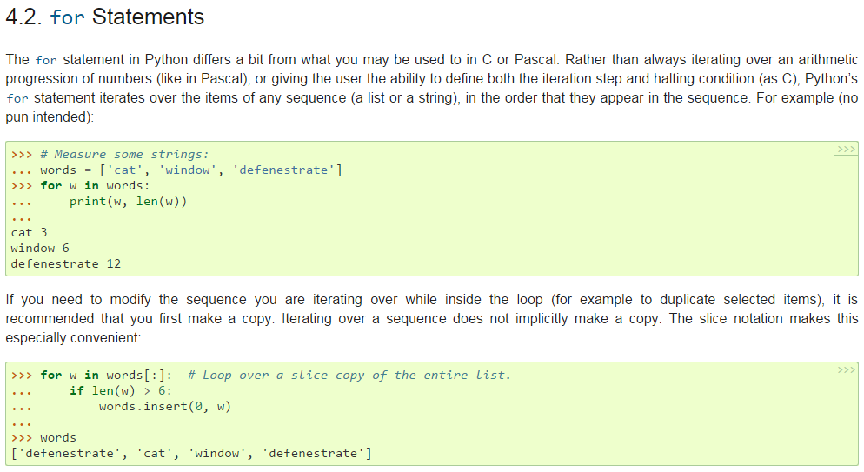To get the most trustworthy information, I went to the python documentation for the version of python I was using - <https://docs.python.org/3/>. I went to the control groups section because that’s where I learned about while loops. The documentation explained that a For loop iterates over any specified/all items in a sequence – e.g. a list, a dictionary, a string, a ‘range()’. This lets me, for example, run my question generator exactly 10 times. This helps me to achieve one of my success criteria – “generate 10 random addition, subtraction, multiplication, or division questions (with 2 numbers only) which are suitable for primary school children”.

### Random number generation and random operator generation:

I went back to the python library for this because I knew that a random function existed in python – I just did not know how to utilise it. I found some information on the random module and two functions caught my attention. [Side note: this means that I do not have to import the whole module. To be efficient I should only import these two functions.]

#### Functions:



This generates a random integer within the boundaries specified. This particular detail is important to meet one of my success criteria – ‘generate 10 random questions which are suitable for primary school children’. If the numbers generated are too large, primary school students might struggle with them.



This picks a random part of any of my sequences. I can utilise this by creating a list with all of the operators. This function would then allow me to generate a random operator; it allows me to meet another one of my success criteria – ‘create a function to generate random operators’.

I may also need to use the shuffle() function in my code.

## Data dictionary

|  |  |  |  |  |
| --- | --- | --- | --- | --- |
| Variable name | Data type | Purpose of variable | Validation | Typical entry value |
| Name | String | It stores the student’s name | Must be a string | John |
| Maxn (scrapped) | Integer | It is the maximum value the random number the student wants to use. | Must be a positive integer | 12 |
| A | Integer | The first (randomly generated) number in a question. | Must be a number between 1 and the number the student has specified. | 5 |
| B | Integer | The second (randomly generated) number in a question. | Must be a number between 1 and the number the student has specified. | 6 |
| Score | Integer | To keep track of how many questions the user has gotten correct | Must be >= 0 and >= 10. | 4 |
| operators | list | To be a list containing the add, subtract and multiply operators. | Must be [‘+’, ‘-‘, ‘*’] | [‘+’, ‘-‘, ‘*’] |
| Op | String | Randomly chosen operator from the list ‘operators’. | Must be either‘+’ or ’-‘ or ’*’. | + |
| ans | integer | To calculate the correct answer to “a op b”. | Must be an integer. | 5 |
| Attempt | Integer | Stores the answer the user provides in order to compare it to the true answer. | Must be an integer. | 6 |

## Algorithm

I chose to use a flowchart to convey my algorithm as it displays my ideas in a logical, clear, and concise manner. This enables any other coder to use my algorithm to create the code in a similar fashion as I.

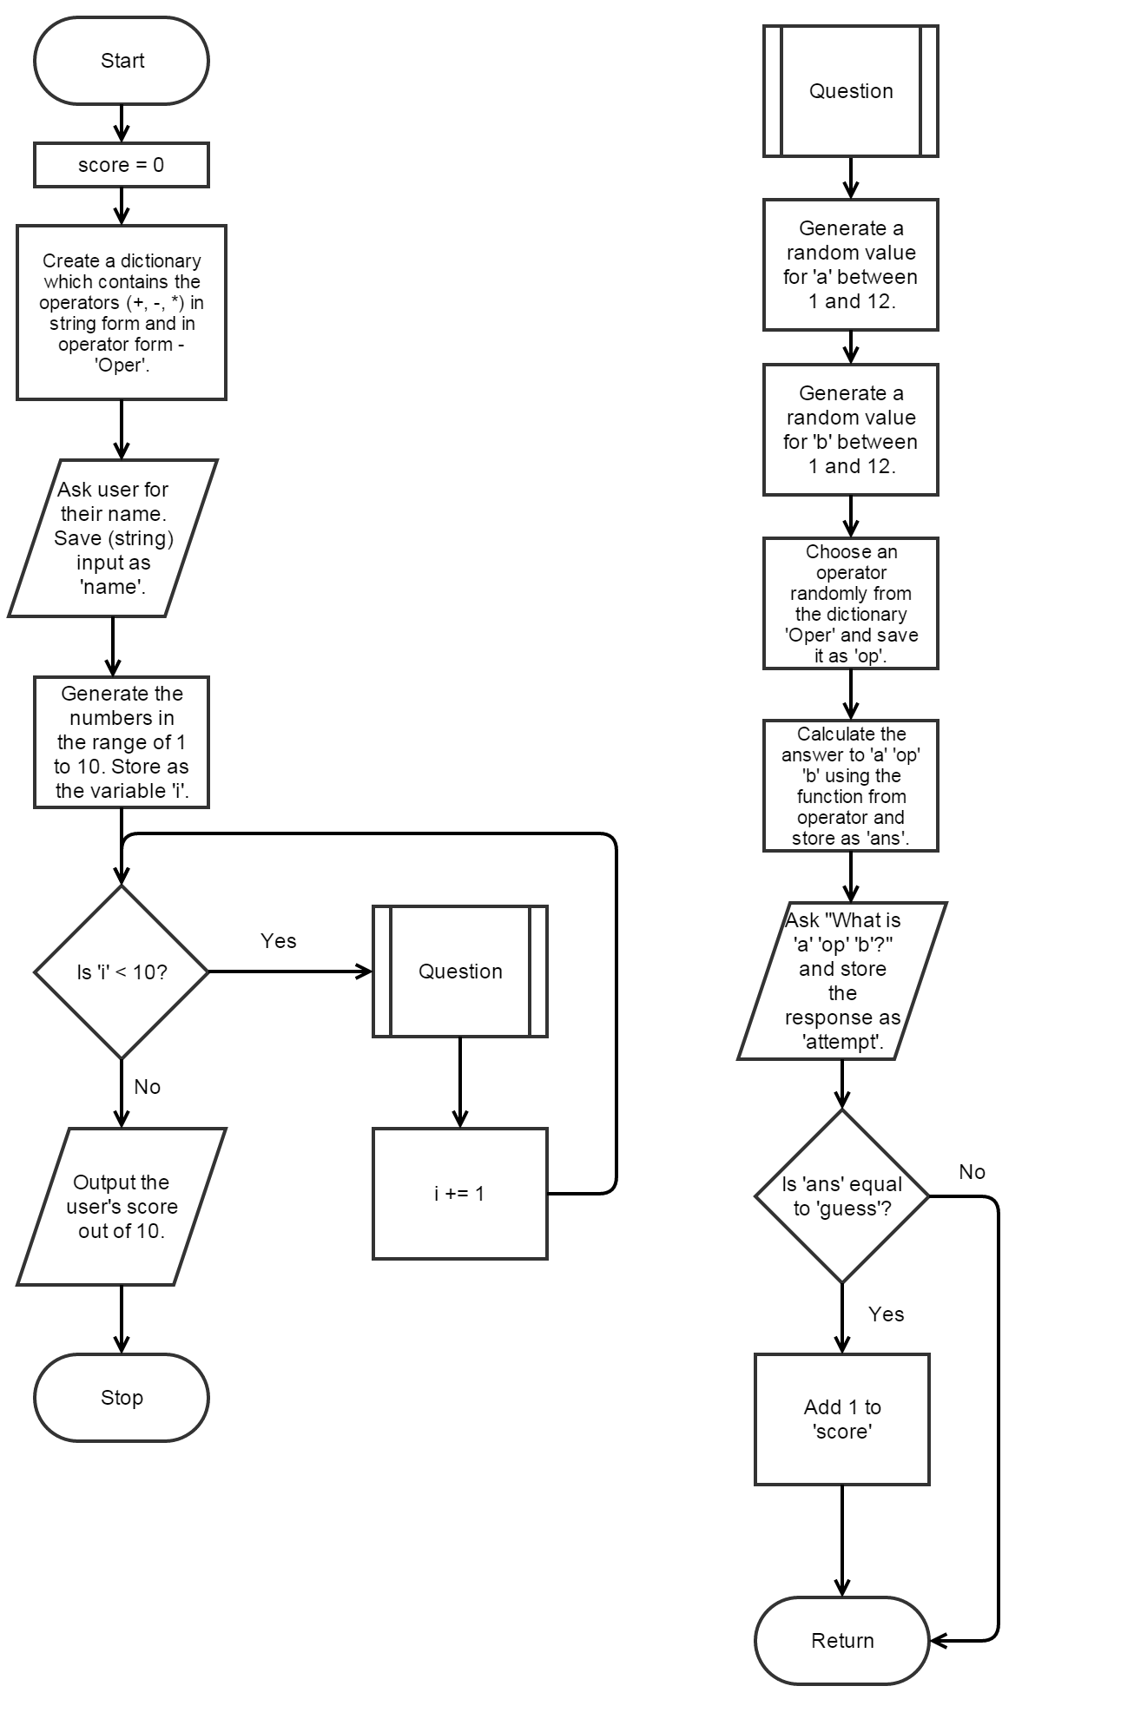

## Version 1

### Code:

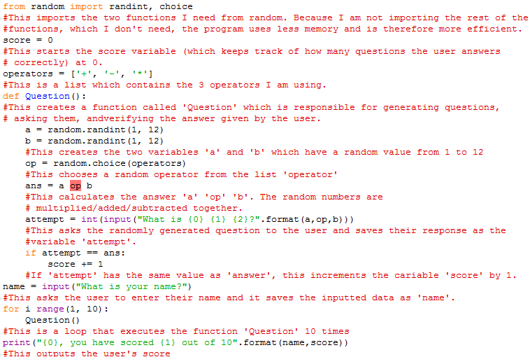

### Test plan:

|  |  |  |  |
| --- | --- | --- | --- |
| Test number | What is being tested | Expected outcome | Actual outcome (Blank = Success, Coloured = Fail) |
| 1 | Compiling | The code should run. The user should be asked to enter their name. |  |

The syntax error is highlighted in red in the code – ans = a op b. I needed to research on how to overcome this issue. Searching ‘a op b’ in google would not yield relevant results. As such, I thought about the function of the line. In essence, the line attempts to calculate the answer to the variable ‘a’ multiplied/summed/subtracted with variable ‘b’. My method was fruitless thus I had to return to research. I needed to discover another method for arithmetic in python – one that could be used with (pseudo) randomised operations.

## Version 2

### Research needed:

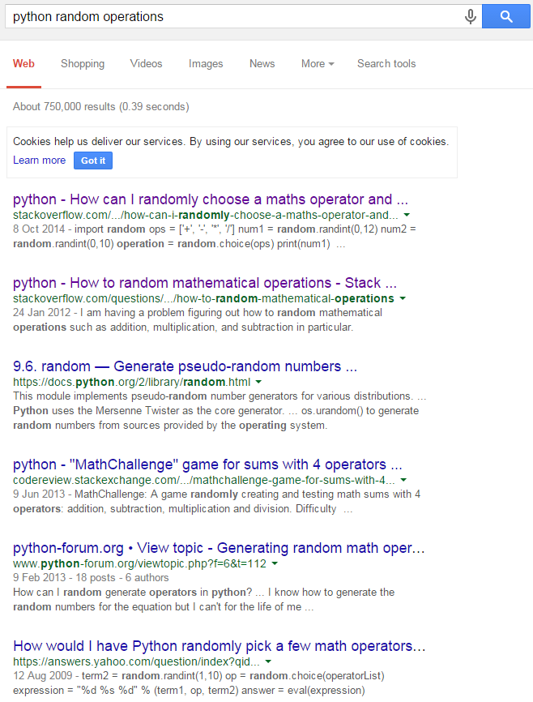

I searched ‘python random operators’ on Google’s search engine and clicked on this link - <http://stackoverflow.com/questions/26260950/how-can-i-randomly-choose-a-maths-operator-and-ask-recurring-maths-questions-wit>. I chose this link through a process of discrimination. Firstly, it is the most relevant link out of the lot; the relevance of each link is determined by the search engine’s algorithm. I trust the algorithm’s judgement as the search engine is highly renowned for its practicality – to the point of having its name in the English dictionary. Secondly, this link has the latest date (in grey) and so it would have the latest information. Information from October 2014 is a lot more reliable, for example, than information from 2009. Finally, I have used the website (stackoverflow.com) before and I can attest to its usefulness. The question and answer website is beneficial for both professional and amateur programmers – such as myself. Also the nature of the voting system on the website is a fantastic filter for potentially trustworthy information. Additionally, the person asking the question can choose the best answer from any one of the potential questionees’ questions.

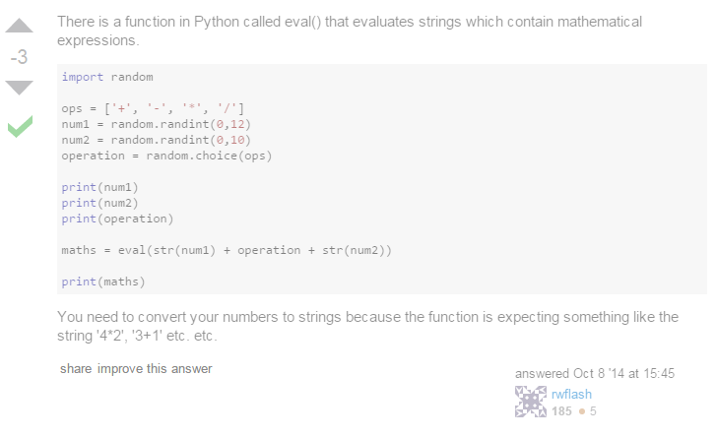

This is the ‘best answer’ from the webpage. Originally, I was sceptical of this answer because of the score but after testing the function in the python shell, all doubt was erased. 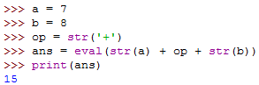

The eval() function is suitable for my code, therefore I will utilise it.

### Code:

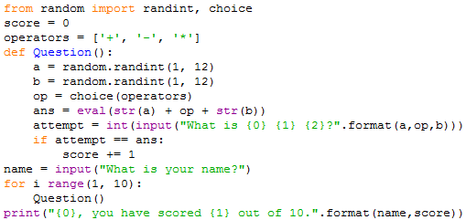

### Test plan:

|  |  |  |  |
| --- | --- | --- | --- |
| Test number | What is being tested | Expected outcome | Actual outcome (Blank = Success, Coloured = Fail) |
| 1 | Compiling | The code should run. The user should be asked to enter their name. |  |

The program did not highlight the syntax error but it did move the pointer to this line:



This led me to believe that a syntax error was in this line. Upon further inspection, I had discovered that I had missed an ‘in’ before the range(). I set out to eliminate all possible syntax errors in version 3.

## Version 3

When I looked over all of my work, I had discovered that my algorithm was missing something which the task required me to do.



I needed to modify my algorithm and therefore my code to fix this issue. The modified parts are circled in red.

### Algorithm V2:

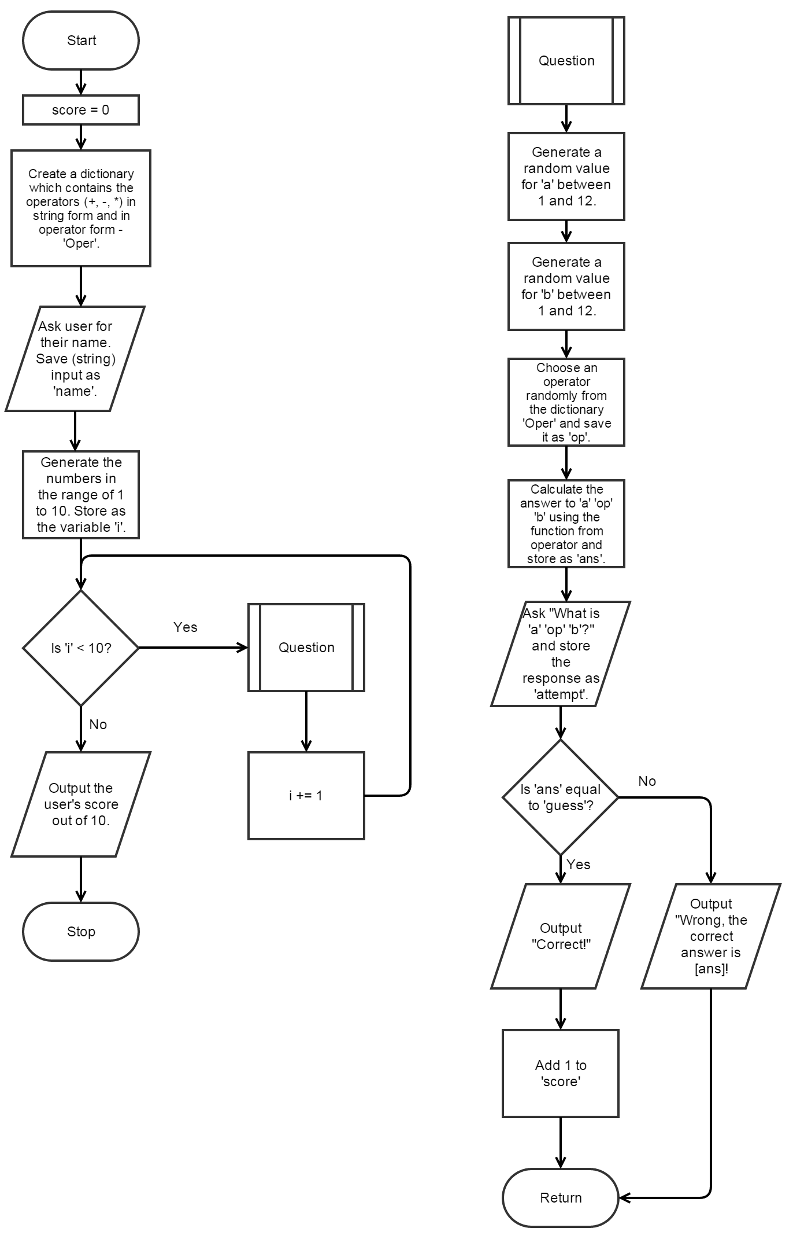

### Code:

All changes have a commented line underneath them.

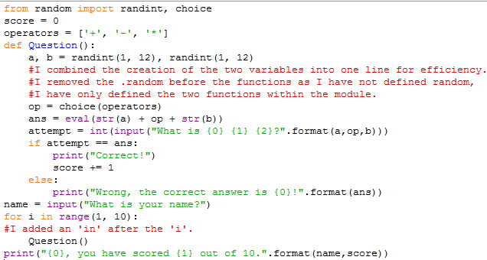

### Test plan:

|  |  |  |  |
| --- | --- | --- | --- |
| Test number | What is being tested | Expected outcome | Actual outcome (Blank = Success, Coloured = Fail) |
| 1 | Compiling | The code should run. The user should be asked to enter their name. |  |

## Version 4

### Research needed:

I searched ‘Python referenced before assignment’ in Google’s search engine. I did not type in my entire error as some of it was intended for a specific variable in my code – ‘score’. I clicked on the latest Stack Overflow link for the aforementioned reasons - <http://stackoverflow.com/questions/18002794/local-variable-referenced-before-assignment-in-python>.

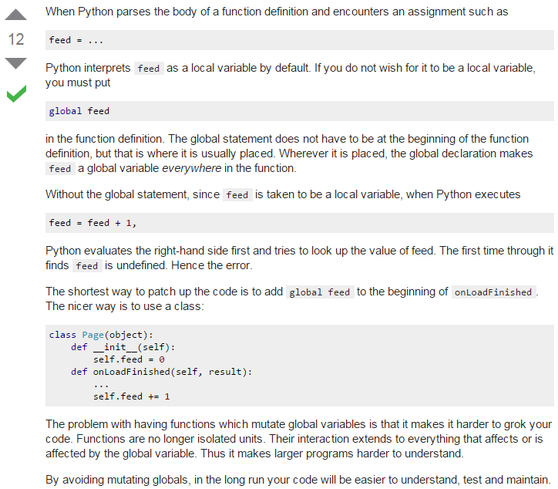

This means that whenever I need to use predefined variables in my functions, I need use this global function. The global function makes an originally local variable usable globally; without it, I cannot use variables inside indented segments that I have created outside of said segments.

### Code:

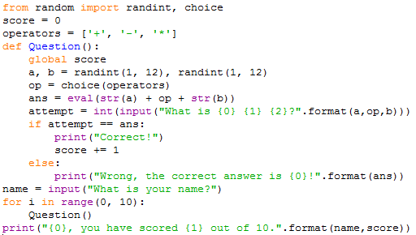

I simply added the line ‘global score’ and changed the 1 in ‘range’ to a 0 to ensure that it would run question 10 times and not 9.

### Test plan:

|  |  |  |  |
| --- | --- | --- | --- |
| Test number | What is being tested | Expected outcome | Actual outcome (Blank = Success, Coloured = Fail) |
| 1 | Compiling | The code should run. The user should be asked to enter their name. |  |
| 2 | User input -valid/valid extreme | The code should run if the inputs are valid |  |
| 3 | User input – invalid/invalid extreme/erroneous | The code should not function if the inputs are invalid. E.g. letters symbols |  |
| 4 | Create two (integer) variables | The program should generate two random numbers |  |
| 5 | Create a function to generate random operators (+, -, *) | The program should generate random operators |  |
| 6 | Ask the student’s name | The program should ask the student for their name |  |
| 7 | Generate 10 random questions which are suitable for primary school children + verify if the answers the student gives are correct or not | The program should generate 10 random questions which are suitable for primary school children and check if the student’s attempts are correct |  |
| 8 | Keep a running score and output it after the questions are done | The program should keep track of the student’s score and output it at the end |  |

## Evaluation

This task needed me to analyse the requirements in detail and design, code, test and evaluate a program which meets the following requirements:

* Create two (integer) variables
* Create a function to generate random operators (+, -, *)
* ask the student’s name
* generate 10 random questions which are suitable for primary school children
* verify if the answers the student gives are correct or not
* keep a running score and output it after the questions are done.

I started the task out by making a note of what I needed to know in python in order to accomplish the task. This helped me in choosing what to research and was the reason why I did not encounter any difficulties during the research phase. I utilised the python documentation as it was the most reliable source – it was created by the same people who created the python programming language. I learnt about for loops and the random module through this.

The variables I planned to use were very straightforward and therefore creating the data dictionary was simple.

For expressing my algorithm, I chose to use a flowchart – created on gliffy.com. I chose to use a flowchart as opposed to pseudo-code as I believe that flowcharts are easier to follow and therefore understand. I utilised a subroutine in my flowchart as it accurately depicts the function I will create inside my code.

When I ran the first version of my code for testing, IDLE stated that there was a syntax error in my line ‘ans = a op b. This error made me realise that my method of calculating the correct answer would not work – python was not capable of accepting operators in the form of strings for its arithmetic. After searching for this issue, I had figured out that I needed the eval() function in my code – which evaluated an entire string. When testing this new function in the next version of my code, I ran into another syntax error. However, this one was just a case of me missing a word in my code – “in”.

Before running the next version (3) of my code, I decided to look over the requirements for the task and it made me realise that I had missed out an aspect of the task. My code did not output if the answer to each question was correct or not. This meant that I also had to rectify my algorithm. In this new version, I had fixed my mistake and I also made a minor optimisation. When I tested this version, IDLE stated that I had “referenced the local variable ‘score’ before assignment.”

In order to overcome this dilemma, I searched a similar phrase on Google. The stack overflow page taught me that I needed to use the global command to solve my issue.

On the whole this task was very successful; I made a few errors along the way but I learned very useful things from them. My understanding on python arithmetic was furthered. Additionally, I found out how python parses functions and what that entails for the code I write. I now know what local variables are and how to replace them if necessary.

# Task 2

## Introduction to the task and success criteria

This task needs me to analyse the requirements in detail and design, code, test and evaluate additional features in my program.

My program should now be able to:

* Assign data to a file
* Store the name, scores, and class of the quiz-taker externally
* Store the data for each class in separate files

## Research of the task

To be able to complete the task, I simply need to be able to write data to file. Specifically, I need to assign data. This is an aspect of python, which is completely alien to me, that I need to research.

### Knowledge needed in Python:

* Write data to a file
* Write data to separate files

### Assigning data to a file:

I searched the phrase “python assigning data file” in Google’s search engine. These words were concise and relevant – qualities which make them ideal to search. “Python” assures that I will only get results relating to the programming language that I use. I excluded the ‘to’ in “assigning data file” because it does not help me in getting more relevant results. 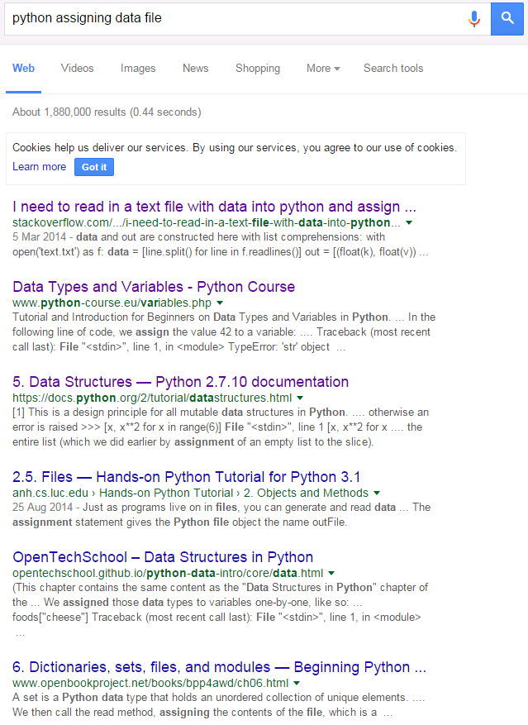

Judging the results on their titles and description alone, my task relates heavily to lists in python. From previous python experience, I knew that lists were ideal for saving this kind of data as I could save all of the data (name & score) for a student in one list. As the first result is the most relevant result based on my search criteria, I went on it. Additionally, stack overflow is a website that I have experience with during the time I spent on my a452 controlled assessment. Also, stack over flow also shows the python commands being used as part of an entire function, or even program, which contrasts greatly with the python documentation which explains commands separately.

Question: 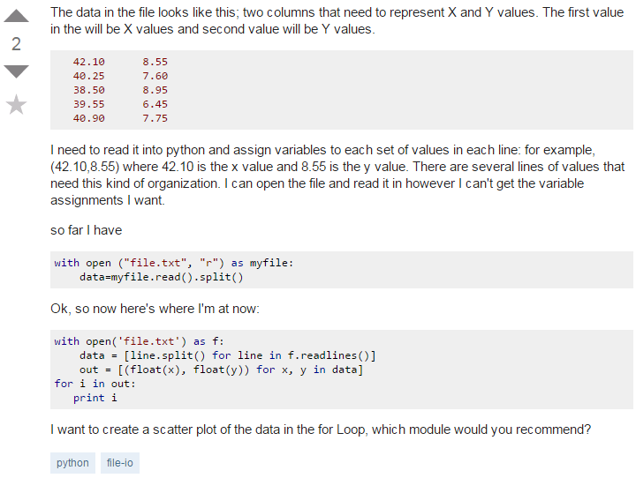

Answer:

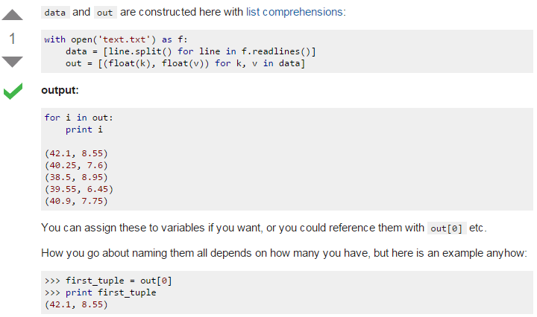

From what I can understand, the open command allows me to read files. The term open implies that it can do more. So, I searched the term and found the documentation which detailed it and discovered that it can have arguments which can make it read or write.

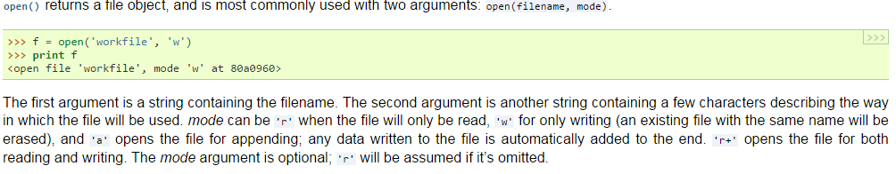

All of this code is for reading data and my code is for writing data to a file. Because I need to read and sort data for task 3, it is important for me to know how to save data in a form that makes it simple to read. The question shows that the data in the file is organised into two columns – which I will emulate in my code. To make my code easier to read, I will store a given student’s score before their name in a line. This would make it so that the first two characters in any line would give the score of a student (09, 10, 04) and the rest of the line would be the name of the person.

### Writing data to a file:

I searched the phrase “python write file” in Google’s search engine. Some of these results were clearly directed towards adept programmers – the website name “learnpythonthehardway” is one such example. I ended up using the simplest looking website - <http://www.afterhoursprogramming.com/tutorial/Python/Writing-to-Files/>.

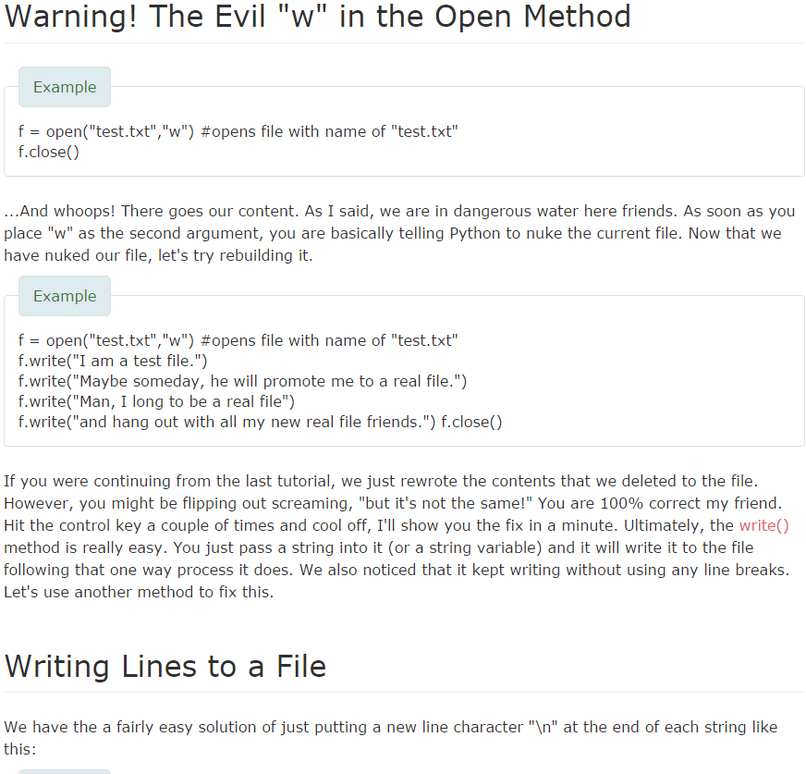

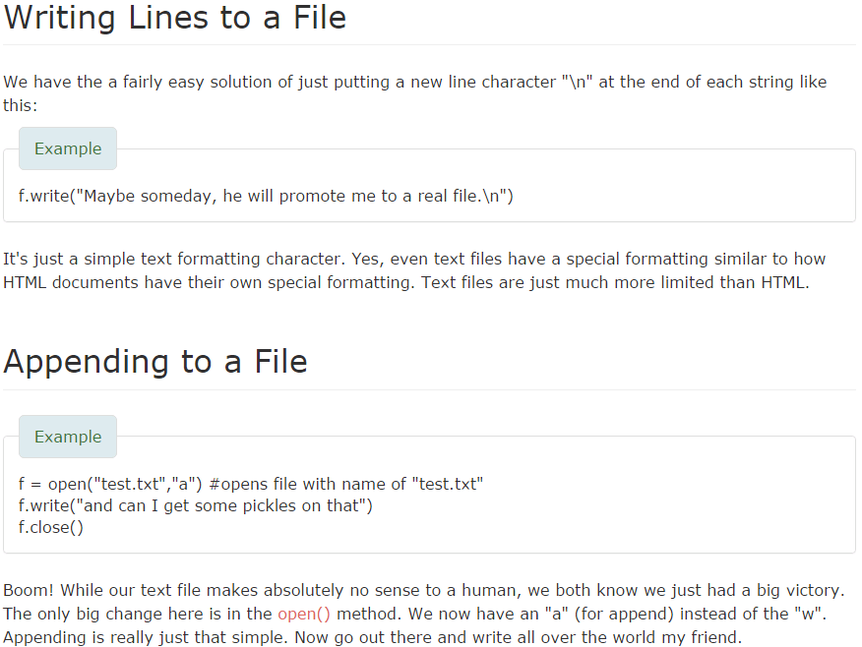

According to this website, I simply have to use the write function. The character “/n” allows me to write to different lines. This is useful as it will allow me to store each student’s data on a separate line which will then make it easier for me to read the data in the next task.

The next section, appending to a file, is the most important for me. If I write to a file, all of my previous data will be deleted. Instead, if I use the append function, my old data will be kept intact and only new data added will be added.

## Data dictionary (continued from task 1)

|  |  |  |  |  |
| --- | --- | --- | --- | --- |
| Variable name | Data type | Purpose of variable | Validation | Typical entry value |
| c | string | To store the class number of the quiz-taker. Also, to store the name of the text file the class’ data is stored in. | Must be an integer. Then, must be a sting. | 1, 2, or 3  Then,  ‘class1.txt’, ‘class2.txt’. ‘class3.txt’ |

## Algorithm

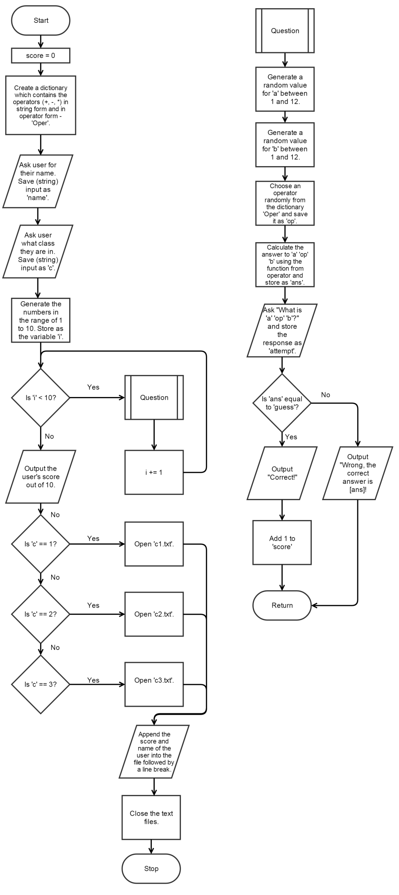

## Version 1

### Code

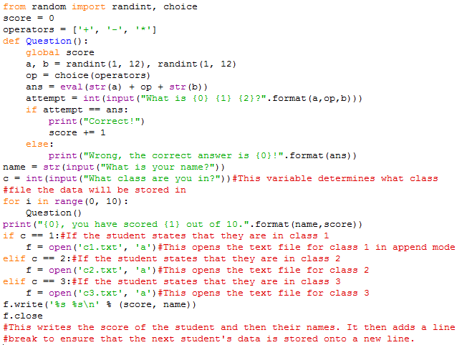

### Test plan

|  |  |  |  |
| --- | --- | --- | --- |
| Test number | What is being tested | Expected outcome | Actual outcome (Blank = Success, Coloured = Fail) |
| 1 | Compiling and Useful message output | The code should run. The user should be asked to enter their class number and name. |  |
| 2 | If the data is stored | The user’s score and name should be appended to the correct class |  |
| 3 | Invalid inputs in questions | The code should crash if the user enters any non-integers when answering the questions. |  |

While testing my code, I realised that I could make it more efficient. It would still follow the same algorithm but it would be more efficient in its execution.

## Version 2

### Code

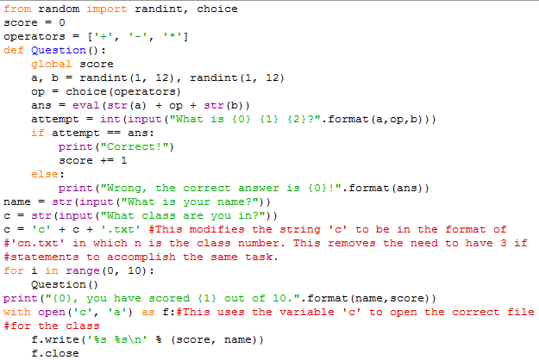

### Test plan

|  |  |  |  |
| --- | --- | --- | --- |
| Test number | What is being tested | Expected outcome | Actual outcome (Blank = Success, Coloured = Fail) |
| 1 | Compiling and Useful message output | The code should run. The user should be asked to enter their name. |  |
| 2 | If the data is stored | The user’s score and name should be appended to the correct class |  |

The code did not save the data to the correct file. In fact, it did not save it to any file. Because of that, I knew that the problem lied in the opening of the file. I realised that I had made the code open the string “c”, which did not exist as a file, instead of the variable ‘c’. Subsequently, I opened removed the quotations from the line and tested it.

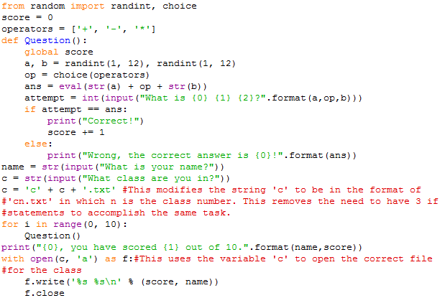

### Test plan (fixed)

|  |  |  |  |
| --- | --- | --- | --- |
| Test number | What is being tested | Expected outcome | Actual outcome (Blank = Success, Coloured = Fail) |
| 1 | Compiling and Useful message output | The code should run. The user should be asked to enter their name and class number. |  |
| 2 | Assign data to a file/ Store the name, scores, and class of the quiz-taker externally | The user’s score and name should be appended to the correct class |  |
| 3 | Store the data for each class in separate files | Each class file should have different data. |  |
| 4 | Invalid inputs in answers | The code should crash if the user enters any non-integers when answering the questions. |  |
| 3 | Invalid inputs in questions | The code should crash if the user enters any non-integers when answering the questions. |  |

## Evaluation

In this task, I had to analyse the requirements in detail and design, code, test and evaluate additional features in my program. The success criteria for this task were as follows:

* Assign data to a file
* Store the name, scores, and class of the quiz-taker externally
* Store the data for each class in separate files

After I had understood what I needed to do for the task, I researched on how to write data to files. This research was quite successful as I managed to learn about opening files and appending them with relative ease. I did that by choosing carefully from the various search results. I picked out websites that were reliable (e.g. the official python documentation) and were simple to understand - e.g. [www.afterhoursprogramming.com](http://www.afterhoursprogramming.com). I also learned about what to avoid in my code like opening in write mode which would erase all the data I had in the file.

When creating the data dictionary, I experienced some difficulty. When I made my code more efficient, I ended up giving the variable ‘c’ two roles: to store the class number of the quiz-taker; to store the name of the text file the class’ data is stored in. Because of that, I was unsure of how to fill out the fields in the table. After thinking about it for a while, I ended up writing both purposes of the code in the table in order to clarify the variable’s function.

For expressing my algorithm, I chose to use a flowchart – created on gliffy.com. I chose to use a flowchart as opposed to pseudo-code as I believe that flowcharts are easier to follow and therefore understand.

My code for task two can be split into two parts: one which closes which file to write to and one that actually writes the score. For the first part, I asked for the user to input what class they belonged to in the same fashion that I asked for their name. I then utilised 3 if statements to determine which text file to open based on what class the user is in. This was a simple solution but not an efficient solution. Subsequently, I created a second version of my code in order to solve the issue of inefficiency. Essentially, I made the variable c have values equal to the name of the file I needed to open using it. This reduced the number of if statements I needed to use for this part of my code from 3 to 0.

On the whole, the task was pretty successful and I only had difficulties regarding efficiency and in the data dictionary.

# Task 3

## Introduction to the task and success criteria

This task requires me to ensure that only the last 3 scores of a student are stored for all 3 classes. Also, I should program, design, code, test and evaluate a program which outputs the scores in 3 different modes: ‘in alphabetical order with each student’s highest score for the tests’; ‘by the highest score, highest to lowest’; ‘by the average score, highest to lowest’.

My program should be able to:

* Ask a student 10 randomised questions
* Record only the last 3 scores of a student
* Store data in a way that allows me to sort afterwards
* Sort in alphabetical order with each student’s highest score for the tests’
* Sort by the highest score, highest to lowest’
* Sort by the average score, highest to lowest’
* Allow teachers to sort and view data
* Read data and append to it

These requirements have made me realise that my code for task two will not allow me to complete this task. As a result, I need to adapt my code for task two so that it is able to store the last 3 scores for a student and, more importantly, so that it is easy to read and sort. Answering the questions and analysing the results are for the purposes of students and teachers respectively. As such, I need to have two different modes in my program.

## Research of the task

### Knowledge needed in Python (crossed out = can do already):

* Storing data in a way that allows me to sort afterwards
* Reading data
* Sorting data
* ~~Average numbers (find the mean)~~

### Methods of storing data:

I have already decided that I will store my data in the plain text format, however, I need to find a way to structure the data. I searched the term ‘python data structures’ into Google’s search engine. I decided to use the official python documentation as I was familiar with it and because it is the most reliable source. Furthermore, I chose the most up to date documentation as it would have documentation on the newer functions of python.

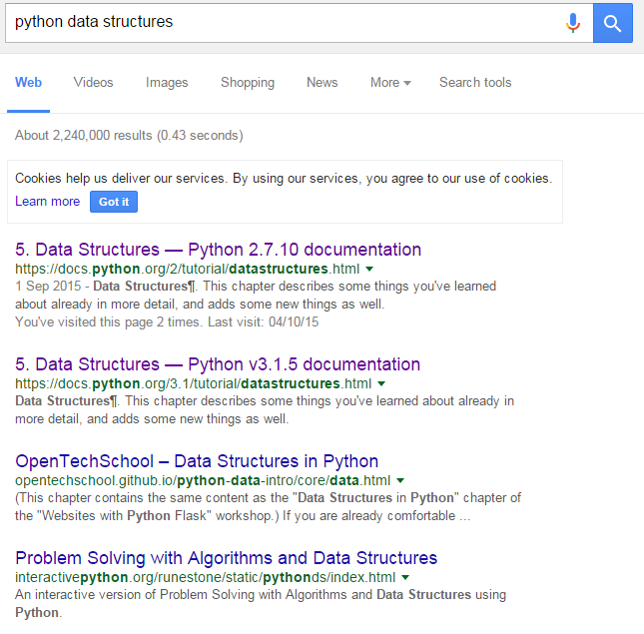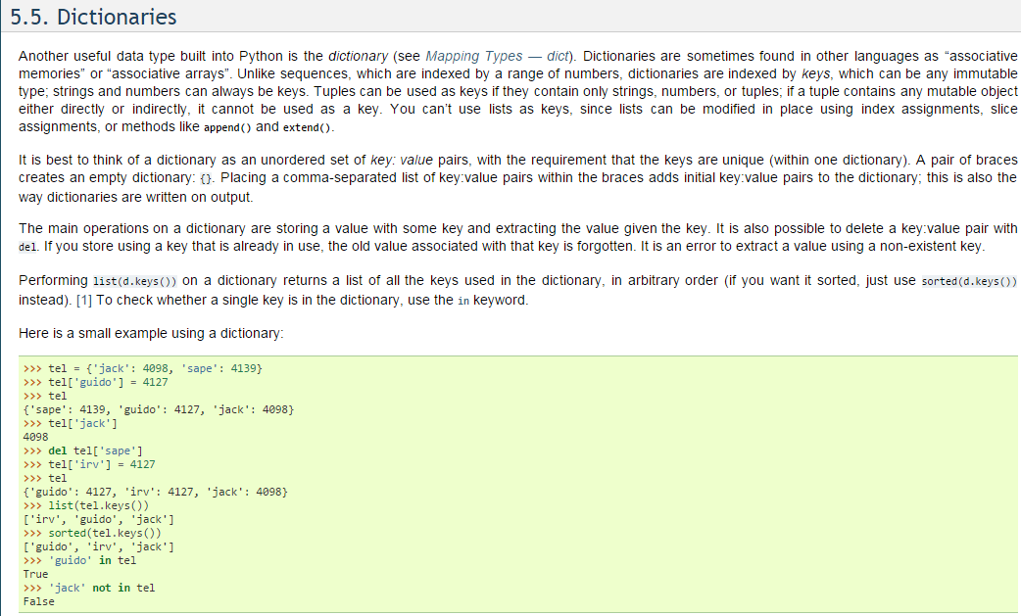

As dictionaries and lists are essential parts of python, I am familiar with them. If I only use lists then the name and scores will be stored side by side. This makes it difficult to sort or average the scores without removing the name from the list. However, if I use dictionaries as well, I can easily link a student’s name with their score without compromising my ability to sort the numbers and calculate averages. The format of my dictionaries will be the following: {‘name’ : [score1,score2,score3]}.

Because I want to have multiple dictionaries (one for each name), I need to find a way to separate them to make it easier to read.

I searched the phrase ‘separate text file’ into Googles’ search engine and discriminated the results.

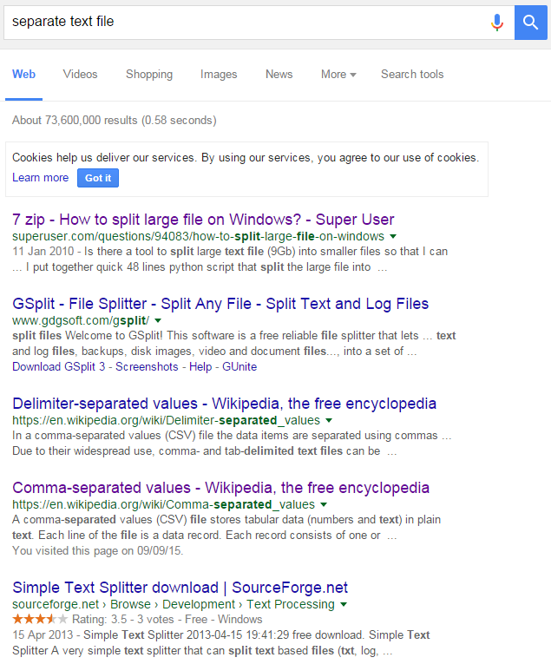

The first result leads to in inquiry about using 7-Zip (a compression program) for a specific task. As I am not using the program, this is not relevant to my needs. The second and fifth results also relate to another program which, again, does not concern me.

The third and fourth results are quite similar – they are both Wikipedia pages concerning the separation of values. I opened both of them in order to compare them.

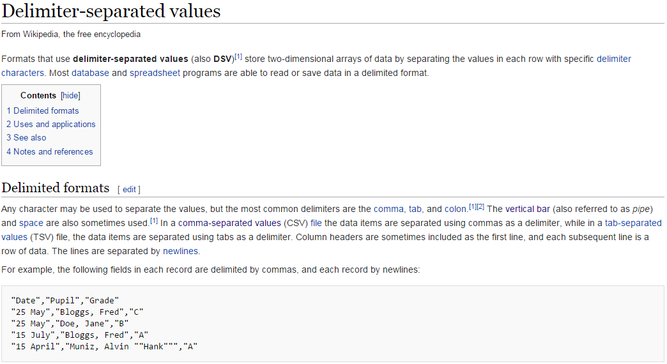

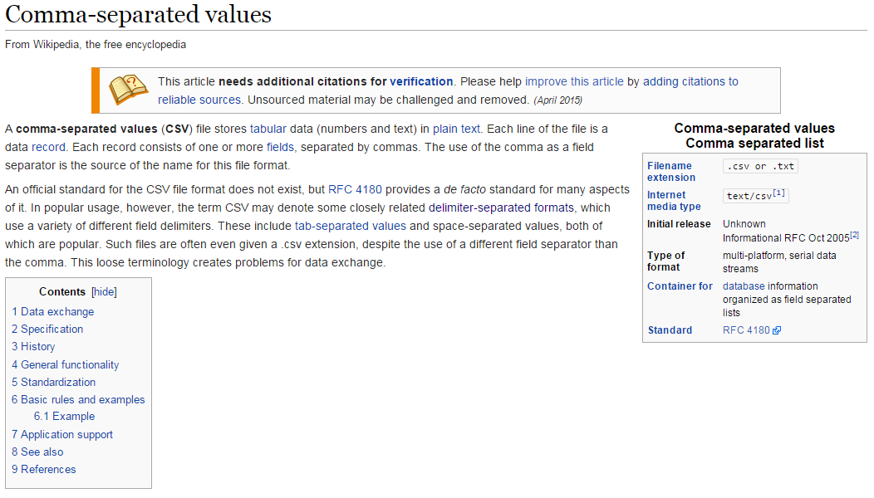

From what I understand, these are both methods to store data in text files. In fact, delimiter-separated values are essentially a more advanced version of comma-separated values. However, they both meet my requirements so I can choose to do either. Comma-separated values has superior documentation and even has a standard – RFC 4180. This leads me to believe that CSVs are more commonly used and will be better supported in general by python libraries and other applications. Therefore, I will use the CSV file format.

### CSV

The Wikipedia page gave me basic information on the CSV file format but it does not provide any python commands related to it. Thus I searched the phrase ‘python CSV’ into Google.

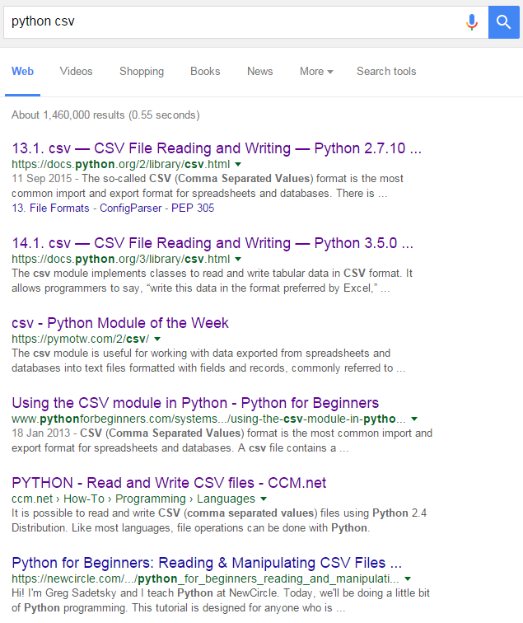

I chose to go to the python documentation for the CSV module as it is a primary source. Furthermore, I chose to use the python 3.5 documentation as it is more up to date. 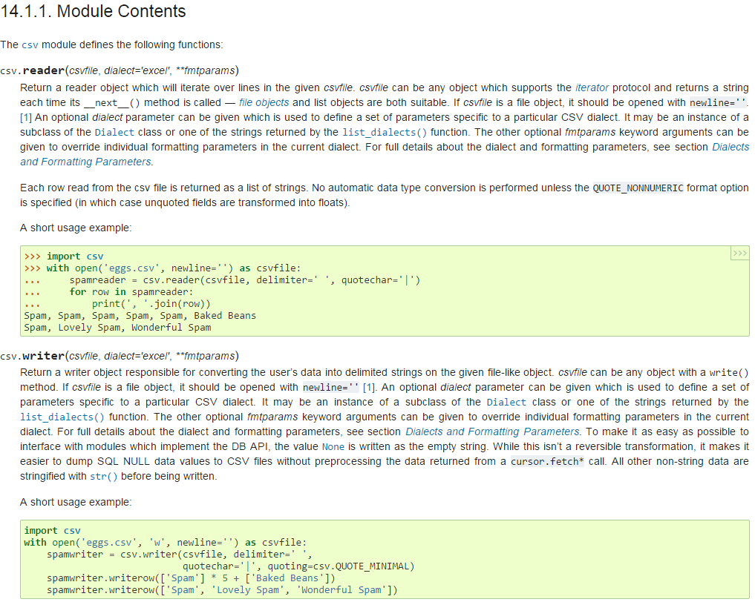

These main two functions are the only ones I need to concern myself with; reader and writer allow me to store and read data in the .csv format. The csv.reader function returns the data from the file as strings by default. This means that I may need to use the eval() function, as I did in task 1, to calculate averages.

### Sorting data

I searched the phrase ‘python sorting data’ in Google’s search engine to find out how to sort data. 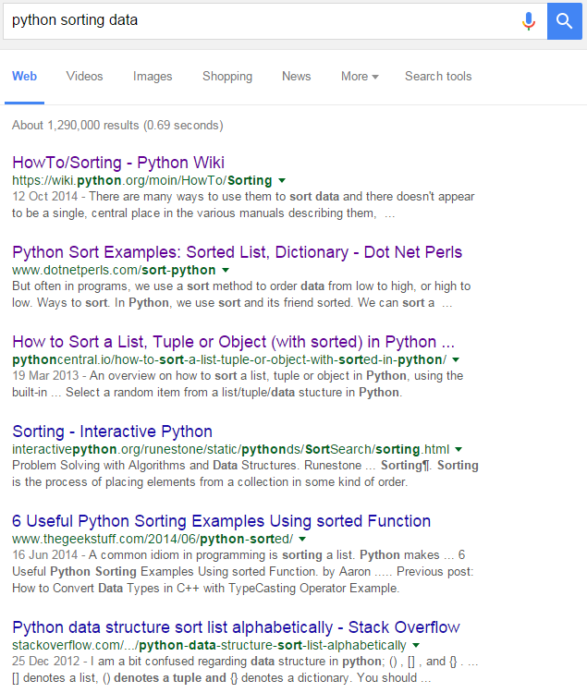

Out of all of the most relevant results, the python wiki was the most up to date resource. Additionally, even though the wiki is maintained by various contributors, it is still a part of the official python website which makes it credible. To further ensure that the data is reliable, I checked the requirements for becoming a contributor on this wiki.

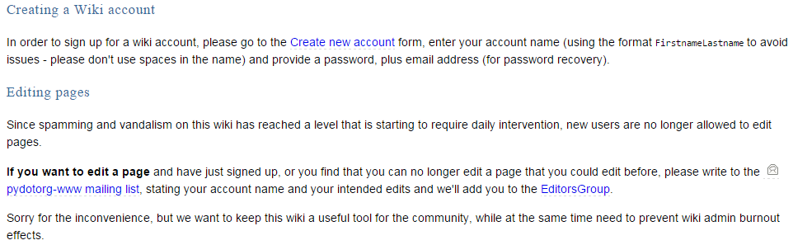

The requirements for editing pages listed here (email with intended edits) show that the admins of the website ensure that the quality of the information on the wiki is absolute.

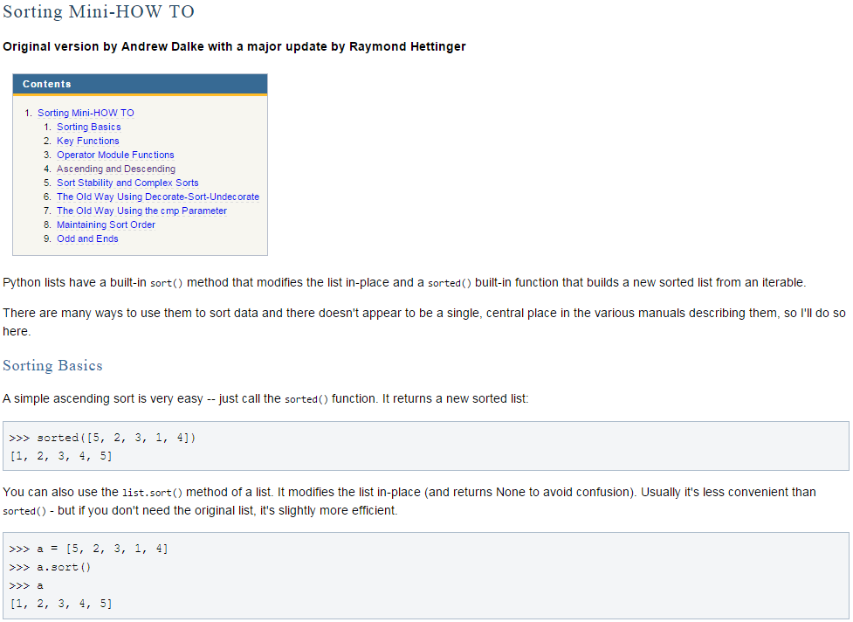

I only need to know sorting to a basic degree as the task only requires me to sort alphabetically and numerically.

## Algorithm

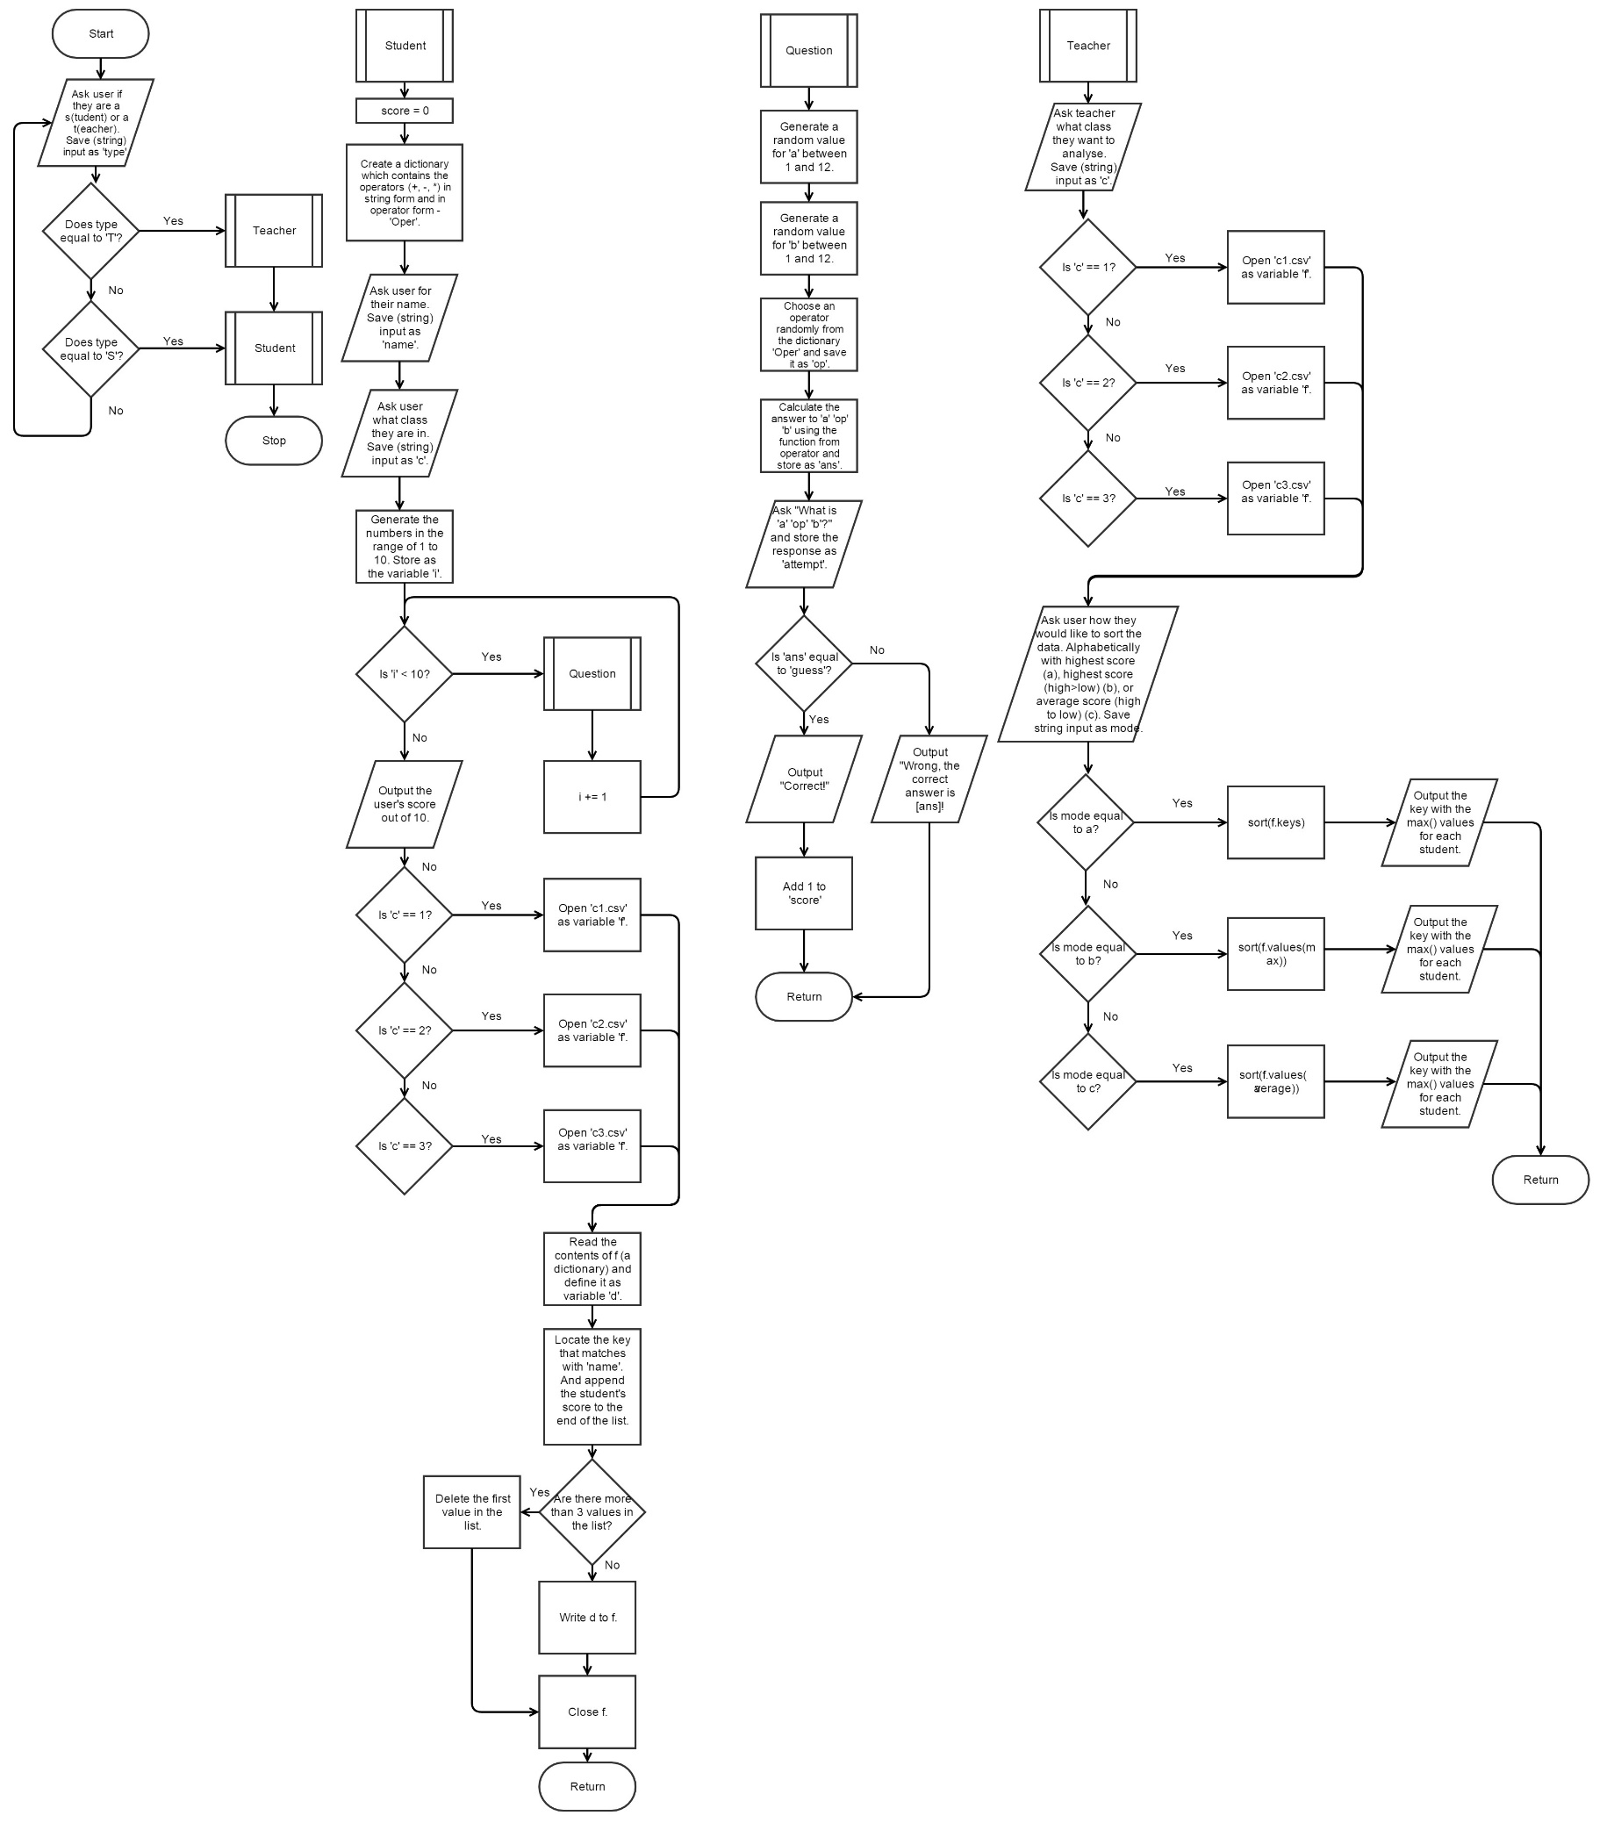

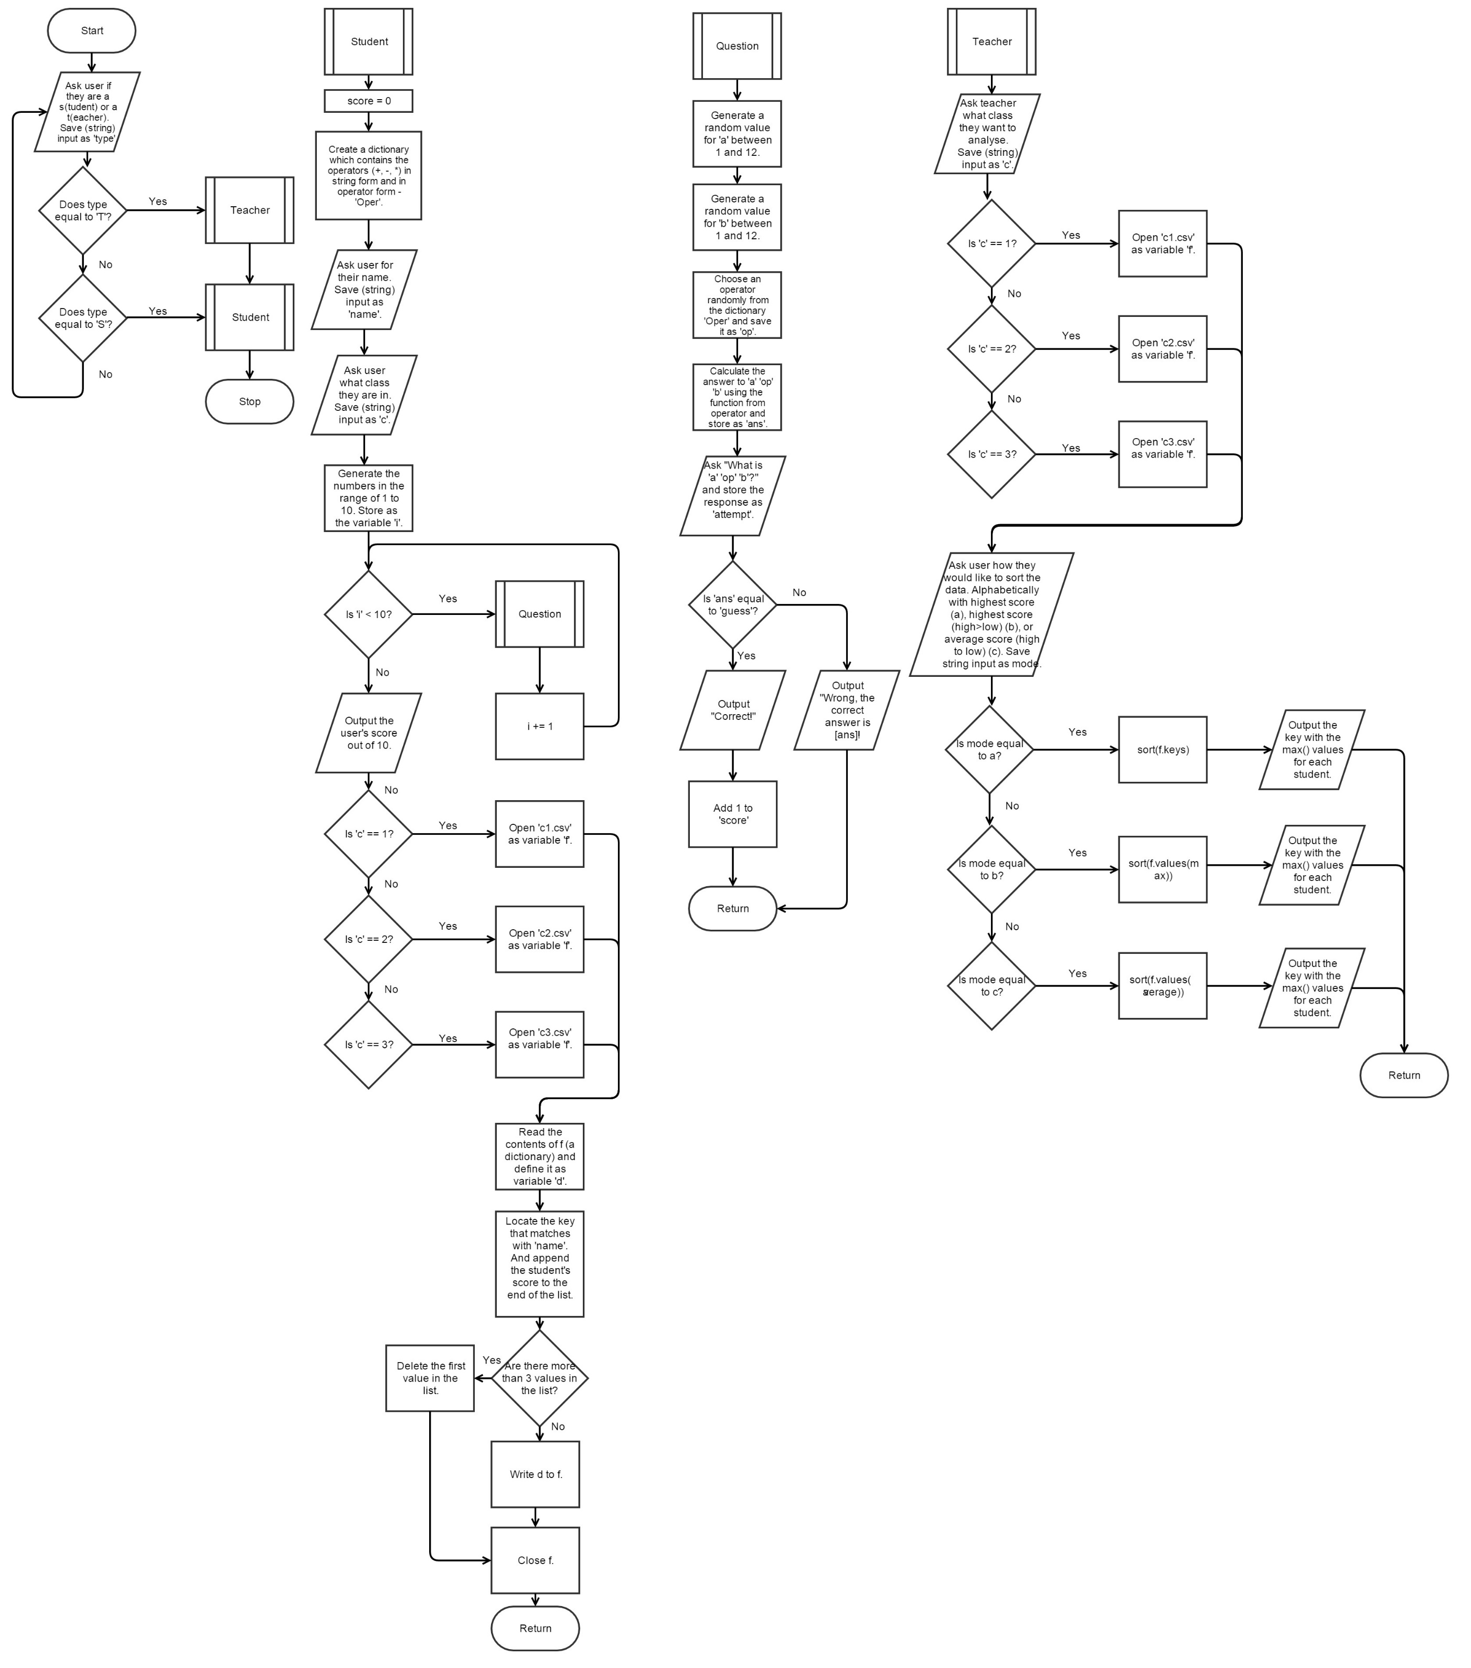

## Version 1

### Data dictionary

|  |  |  |  |  |
| --- | --- | --- | --- | --- |
| Variable name | Data type | Purpose of variable | Validation | Typical entry value |
| Name | String | It stores the student’s name | Must be a string | John |
| A | Integer | The first (randomly generated) number in a question. | Must be a number between 1 and the number the student has specified. | 5 |
| B | Integer | The second (randomly generated) number in a question. | Must be a number between 1 and the number the student has specified. | 6 |
| Score | Integer | To keep track of how many questions the user has gotten correct | Must be >= 0 and >= 10. | 4 |
| operators | list | To be a list containing the add, subtract and multiply operators. | Must be [‘+’, ‘-‘, ‘*’] | [‘+’, ‘-‘, ‘*’] |
| Op | String | Randomly chosen operator from the list ‘operators’. | Must be either‘+’ or ’-‘ or ’*’. | + |
| ans | integer | To calculate the correct answer to “a op b”. | Must be an integer. | 5 |
| Attempt | Integer | Stores the answer the user provides in order to compare it to the true answer. | Must be an integer. | 6 |
| c | string | To store the class number of the quiz-taker. Also, to store the name of the text file the class’ data is stored in. | Must be an integer. Then, must be a sting. | 1, 2, or 3  Then,  ‘class1.txt’, ‘class2.txt’. ‘class3.txt’ |
| type | String | It stores the type of user the user is | Must be a string. Must be T or S | T |
| f | Dictionary | It contains the name and the last 3 scores (in a list) of the students | Key must be a string. List must contain 3 integers. | ‘Manav’:[10,10,10] |
| d | Dictionary | A copy of f. Made in order to update the list of scores. | Key must be a string. List must contain 3 integers. | ‘Parth’:[1,0,1] |

### Code

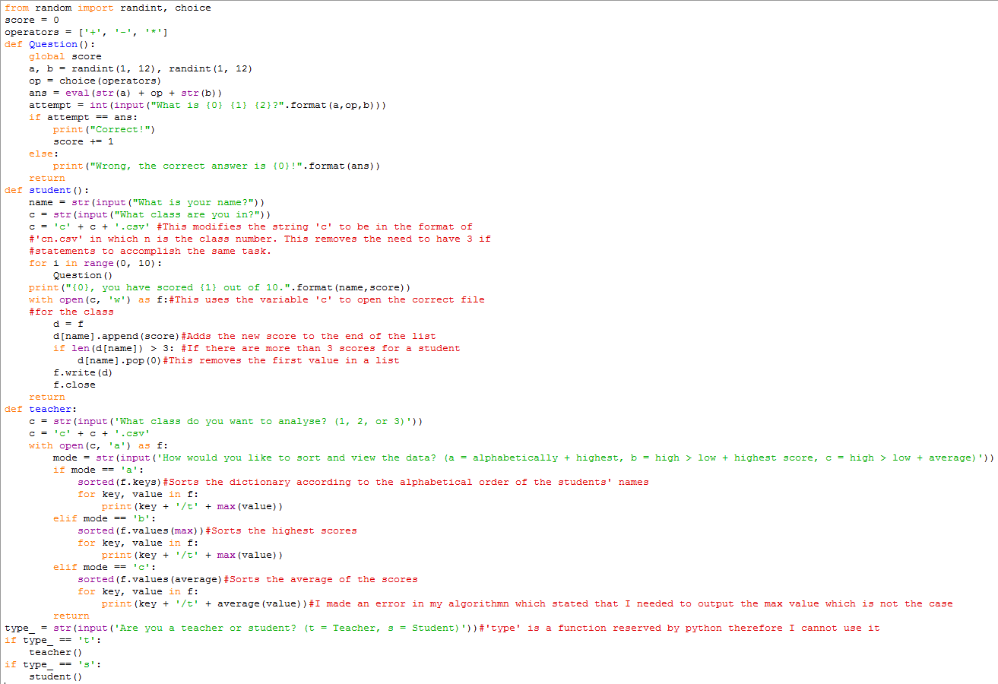

### Test plan

|  |  |  |  |
| --- | --- | --- | --- |
| Test number | What is being tested | Expected outcome | Actual outcome (Blank = Success, Coloured = Fail) |
| 1 | Compiling | The code should compile |  |

## Version 2

After having another look at the requirements, I realised that my understanding of them was partially incorrect. Only the teacher(s) should have access to the results of the classes. As it is now, any student could claim that they are a teacher and have access to the data therefore I need to utilise authentication measures. Additionally, the code that I have incorporates the teacher and student aspect of the task. While this is more efficient in theory, in practice it makes the code harder to debug as it would be harder to detect where all of the faults in the code lie. In summary, I need to separate the teacher and student aspects of the code until they are fully functional independently.

I can use the research that I have already performed to amend my code. I can use dictionaries as a form of authentication. I can have different passwords for the three classes (as keys) which have the students’ data as values. This means that I need to store a student’s name and scores as one list and not as one dictionary. This will also be more useful ultimately as lists, unlike dictionaries, can be ordered. In further documentation, I will be calling the lists for the classes ‘lists’ and I will call the lists for each student ‘sub-lists’ in order to avoid confusion. Additionally, I will not make another algorithm for this task as the current one only has minor issues.

I will consider version 2 of my code (for teachers and students) finished when it fits the criteria. Then, I will create a version 3 of my code which includes validation measures in order to ensure that my code does not crash if the user inputs anything unexpected – for example a letter for arithmetic question. Also, I will only have one program for teachers and students in version 3 but I will implement authentication measures so that unauthorised parties cannot use the teacher part of the code.

### Data dictionary

|  |  |  |  |  |
| --- | --- | --- | --- | --- |
| Variable name | Data type | Purpose of variable | Validation | Typical entry value |
| C | Integer | To store the student’s class | Must be 1,2, or 3 | 2 |
| F | String |  | None | ‘{1: [['Manav', 10, 10, 10], ['AVraj', 3, 1, 2], ['Parth', 1, 9, 2]], 2: [['Viraj', 3, 1, 2], ['X', 4, 7, 2], ['Newcomer', 0, 6]], 3: [['Y', 9, 7, 2], ['Z', 3, 6, 2]]}’ |
| A | Dictionary |  | Must contain | {1: [['Manav', 10, 10, 10], ['AVraj', 3, 1, 2], ['Parth', 1, 9, 2]], 2: [['Viraj', 3, 1, 2], ['X', 4, 7, 2], ['Newcomer', 0, 6]], 3: [['Y', 9, 7, 2], ['Z', 3, 6, 2]]} |
| classdata | List |  |  |  |
| Mode | String |  | Must be a, b or, c |  |
| Maxi | Integer |  |  |  |
| Average | Integer |  |  |  |
| Inlist | Boolean |  | Must be True or False |  |
| Name | String | It stores the student’s name | Must be a string | John |
| A | Integer | The first (randomly generated) number in a question. | Must be a number between 1 and the number the student has specified. | 5 |
| B | Integer | The second (randomly generated) number in a question. | Must be a number between 1 and the number the student has specified. | 6 |
| Score | Integer | To keep track of how many questions the user has gotten correct | Must be >= 0 and >= 10. | 4 |
| operators | list | To be a list containing the add, subtract and multiply operators. | Must be [‘+’, ‘-‘, ‘*’] | [‘+’, ‘-‘, ‘*’] |
| Op | String | Randomly chosen operator from the list ‘operators’. | Must be either‘+’ or ’-‘ or ’*’. | + |
| ans | integer | To calculate the correct answer to “a op b”. | Must be an integer. | 5 |
| Attempt | Integer | Stores the answer the user provides in order to compare it to the true answer. | Must be an integer. | 6 |

### Teacher Testing

#### First test

The first issue with my code lies in my initial misunderstanding of how dictionaries work. I was under the impression that they were essentially a list and could consequently be ordered and sorted. In reality, dictionaries are used to contain values which correspond to keys. Therefore, my method of storing the students’ name alongside their scores, in list form, as key, value pairs (e.g. Manav : [1,2,3]) was incorrect. My approach now is to store the classes as the keys and the names and scores of the entire class as values i.e. 'teacher1': [['Manav', 8, 10, 9], ['Vraj', 3, 2, 2], ['Parth', 1, 10, 2]]. I understood this by finding a tutorial on how to use the various functions of a dictionary - <http://www.tutorialspoint.com/python/python_dictionary.htm>. Going back over the python documentation for dictionaries (<https://docs.python.org/3/tutorial/datastructures.html>.), I was able to solidify my understanding of this.

Initially, I tested my idea by creating a test file by creating a dictionary and attempting to retrieve data from it.

##### Code



##### Output



Having conducted this test, I now know how to structure my data in a useful manner.

#### Second test

I then copied the dictionary into a text file and attempted to read from it.

##### Code

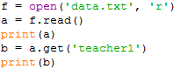

##### Output



The attribute error indicated to me that my program was storing the contents of the text file as a string, rather than a dictionary. So, I searched ‘store dictionary in text file python’ to find a solution. I clicked on this link - <https://bytes.com/topic/python/answers/613359-writing-dictionary-data-file>. This website indicated that I had to use the eval() function which I incorporated in version two of my code for this test.

#### Second test (V2)

##### Code

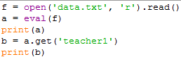

##### Output

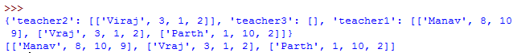

Now, the code treats the contents of the text file like a dictionary.

#### Third test

##### Research

Now, I need to ensure that I can sort my data. I know how to successfully sort data in a list, however, I do not know how to sort a list based on the (sub-)lists inside it.

I searched the phrase ‘sort list inside a list’ as it was the simplest way that I can explain my problem. Due to possible time concerns, I did not discriminate the links as I had already used a lot of my allocated time on the teacher segment of the code.

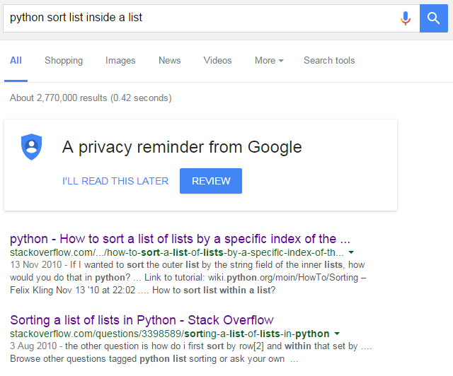

First link:

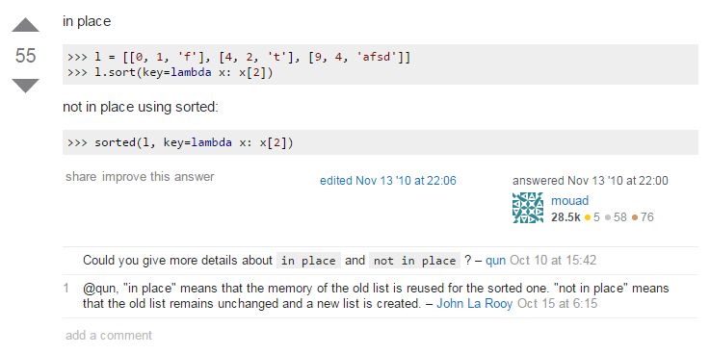

Second link:

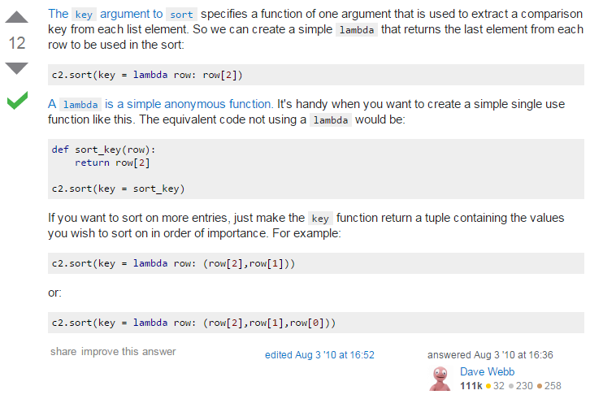

Both of these threads on stack overflow were similar in the sense that they both utilised the lambda function. The second link explained the function to me. Essentially, it can be used to create a temporary function. This makes it ideal for my code as it would allow the function to vary for each mode of my code. This function therefore makes my code more efficient. The function allows me to sort each class list by the numbers within the sub-lists.

##### Code

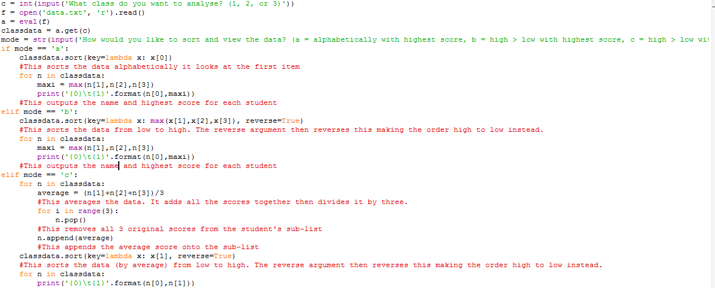

##### Test plan

|  |  |  |
| --- | --- | --- |
| Test number | Expected outcome | Actual outcome (Blank = Success, Coloured = Fail) |
| 1 | The code should sort and output the class list for class 1 alphabetically with the highest score |  |
| 2 | The code should sort and output the class list for class 2 from high to low with the highest score |  |

I realised that the code was using all 3 scores for the average. Therefore in the event that a student has less than 3 scores, the code crashes as it is out of range. I will attempt to debug this in my teacher code. Having conducted these tests regarding the reading of data, I can now attempt to write up my code for the teachers.

### Teacher Code

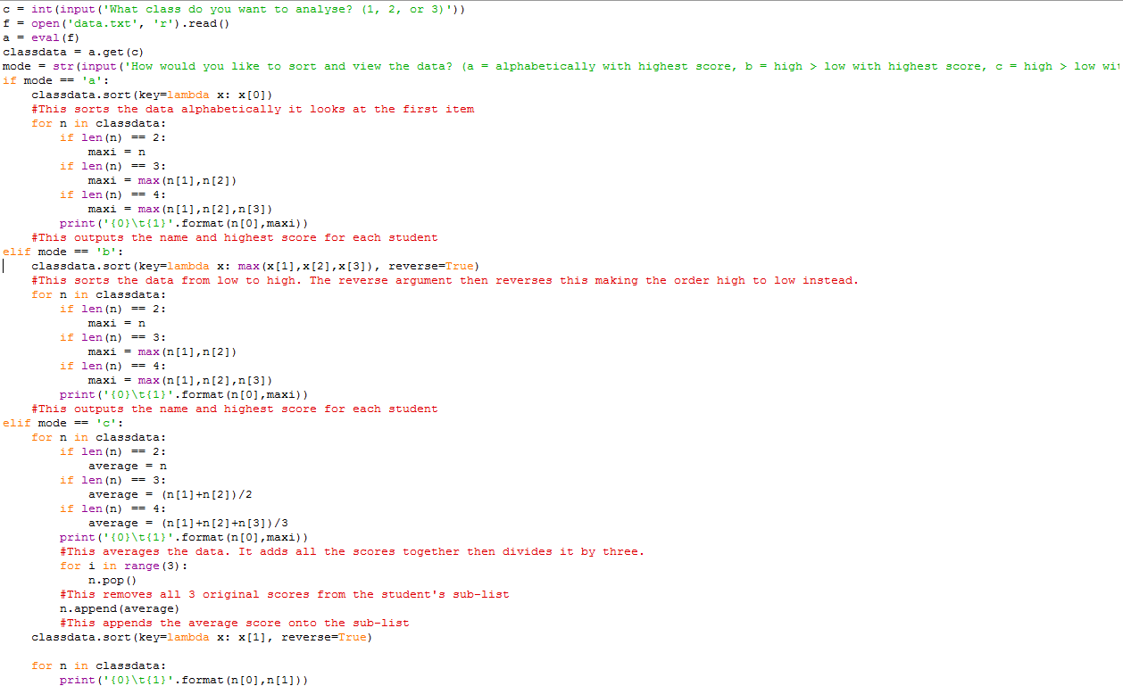

##### Test plan (based on success criteria)

|  |  |  |
| --- | --- | --- |
| Test number | Expected outcome | Actual outcome (Blank = Success, Coloured = Fail) |
| 1 | The code should sort and output the class list for class 1 alphabetically with the highest score |  |
| 2 | The code should sort and output the class list for class 2 from high to low with the highest score |  |

### Student Testing

#### First test

The first issue with my code involves my confusion in the lists and dictionaries I had used. Firstly, my code was reading the contents of the data file as a string rather than a dictionary. Having done the teacher code, I now know that I needed to use the eval() function in order to convert the string into a dictionary. Secondly, I was storing each student’s data as a separate entry in my dictionary. This was a wrong choice as data in a dictionary cannot be sorted. With that in mind, I have planned some tests in order to ensure that I can do version 2 of my student code correctly. In this test, I am checking if the student who is taking the test already has an entry in his class’s list. If an entry already exists, then there is no need to make a new list for the student.

##### Code

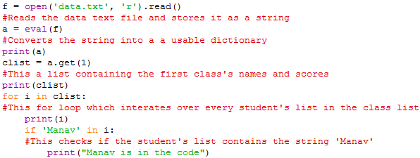

##### Test plan

|  |  |  |
| --- | --- | --- |
| Test number | Expected outcome | Actual outcome (Blank = Success, Coloured = Fail) |
| 1 | The code should run. After Manav’s sub-list has been output, It should output my message. For other sub-lists, it should not output anything. |  |

Having conducted this test, I now know how to check if the student currently taking the test is already in the list.

#### Second test

This second test simply adds a (dummy) score onto a person’s list if it already exists. If the student has more than 3 scores then their oldest score is deleted. Additionally, if the student’s name is not in the list, a new list is created for the student.

##### Code

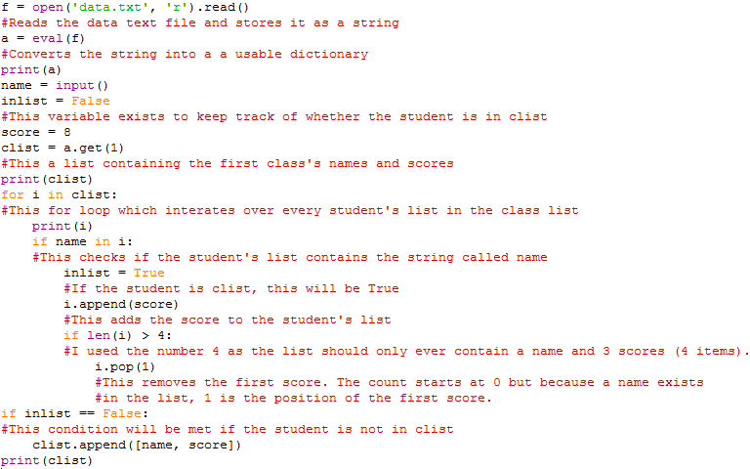

##### Test plan

|  |  |  |  |
| --- | --- | --- | --- |
| Test number | What is being tested | Expected outcome | Actual outcome (Blank = Success, Coloured = Fail) |
| 1 | If the program recognises that a student has a sub-list | The program should recognise that Parth has a sub-list and then it should append ‘score’ to the sub-list.  Also, it should not remove any of his scores as he will not exceed the threshold of 4 items in his list. |  |
| 2 | If the program recognises that a student’s sub-list has more than 4 items i.e. more than 3 scores. | The program should recognise that AVraj’s sub-list will exceed the threshold of 4 items thus it should remove his first score. |  |
| 3 | If the program recognises that a student does not have a sub-list it should create one | The program should recognise that ‘Newcomer’ does not exist. So, it should create one. |  |

#### Third test

Now I know how to add a score onto a person’s list if it already exists; delete the oldest score if there are more than 3; create a new list for a new student. So far, I have been creating new variables to modify the lists. I now need to write the modified data to the data file. This will be the final test which I need to conduct before I create the student code.

##### Code

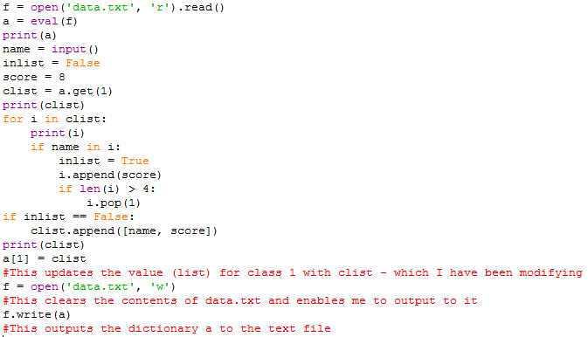

##### Test plan

|  |  |  |  |
| --- | --- | --- | --- |
| Test number | What is being tested | Expected outcome | Actual outcome (Blank = Success, Coloured = Fail) |
| 1 | If the updated dictionary ‘a’ is output to the data file | AVraj’s scores should change from [3,1,2] to [1,2,8] |  |

#### Third test (V2)

The contents of my data file were erased because of the ‘w’ argument I had used in my open() function. This is one risk of using the this line of code, however, if I ensure that my final code does not have any errors which cause this and I keep regular backups of my data file during development, this should not be much of a problem. I did keep a copy before I conducted this test thus I can easily restore the file. The variable ‘a’ was a dictionary and therefore it could not be output to the data file. In order to overcome this, I simply have to convert it into a string before it is output.

##### Code

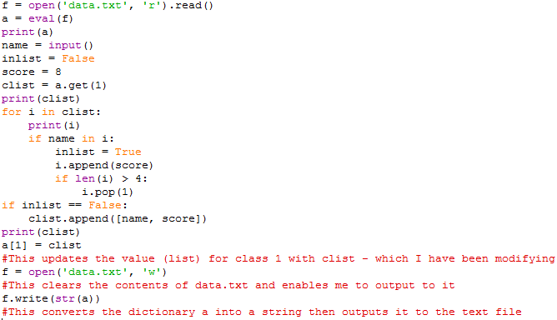

##### Test plan

|  |  |  |  |
| --- | --- | --- | --- |
| Test number | What is being tested | Expected outcome | Actual outcome (Blank = Success, Coloured = Fail) |
| 1 | If the updated dictionary ‘a’ is output to the data file | AVraj’s scores should change from [3,1,2] to [1,2,8] |  |

#### Third test (V3)

While the shell did not give me error messages, my text file was still deleted. Personally I thought that this was because f was being unassigned. I plan to remedy this by using the same measure that I had used for reading the file. I will place the write function on the same line that I have the open() function on.

##### Code

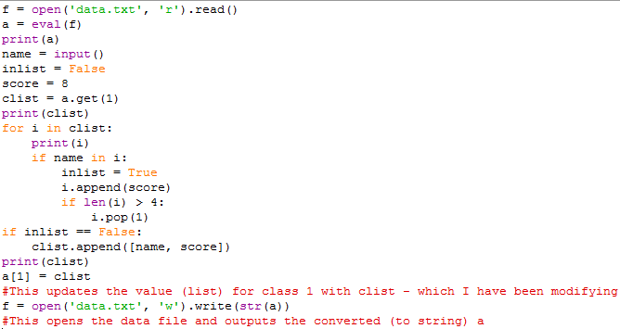

##### Test plan

|  |  |  |  |
| --- | --- | --- | --- |
| Test number | What is being tested | Expected outcome | Actual outcome (Blank = Success, Coloured = Fail) |
| 1 | If the updated dictionary ‘a’ is output to the data file | AVraj’s scores should change from [3,1,2] to [1,2,8] |  |

Having conducted these tests, I feel like I can create a working version of the student program.

### Student Code

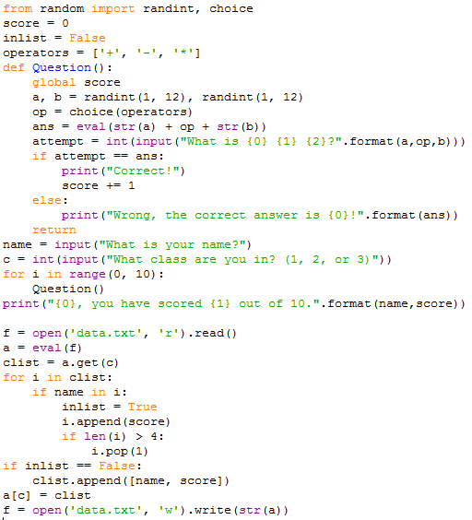

##### Test plan (based on success criteria)

|  |  |  |  |
| --- | --- | --- | --- |
| Test number | What is being tested | Expected outcome | Actual outcome (Blank = Success, Coloured = Fail) |
| 1 | Ask a student 10 randomised questions | The program should ask a student 10 random questions |  |
| 2 | Only last 3 scores recorded | Every student should only have a maximum of 3 scores |  |
| 3 | Reading data and appending to it | The program should read Newcomer’s sub-list and append the new score onto it. | Before:  After scoring 6 in a test: |

### Student Code (V2)

Upon looking at the results of my testing, I realised that some of the answers in my quiz were negative numbers. As the children using my program are primary school children, they may struggle with that concept thus I should ensure that such questions are not asked. Additionally, my code has no validation which means that some variables could have incorrect values e.g. name may have an integer. Furthermore, program needs to be reset in order to be used again which is not ideal. For the next version of my code, I will address these issues.

I searched ‘python validation’ in Google’s search engine in order to figure out how to implement validation in my code. The most relevant result (<http://www.101computing.net/number-only/>) used the ‘try’ built-in function in Python.

Additionally, I did the log and the testing simultaneously as it was the best method of ensuring that whatever code I developed actually carried out its purpose.

#### Development log

|  |  |
| --- | --- |
|  |  |
| Firstly, I placed all of my code inside a while loop. The condition for this loop is ‘True’ and therefore it will run forever. | However, I do not want my code to run forever. If a user wants to exit the program, the option should be available. If the user enters ‘True’ the program should exit. If they enter anything else, the program will keep running. I did not implement validation for this as the program should continue if the user does not explicitly state that they wish to exit the program. |
|  |  |
| When I tested my code, I realised that the program never actually looped |  |
|  |  |
| Next, I wanted to add validation to my code. | Now, my code constantly tries to ask the user for their answer to the question. If the user’s input is invalid (i.e. non-integer) then it will continue the loop and consequently ask the user for their name again. |
|  |  |
| Then, I ensured that name would be a string so that it could be sorted. | I also added a further check for this variable. As there are only 3 classes, there should only be 3 possible values for this variable. |
|  |  |
| Next, I had to modify my code so that there would be no negatives for the answers. I could do this in a number of ways. My initial idea was that I could modify my randomly generated numbers. The answer to a question can only be negative if two conditions are met. Firstly, the operator must be negative as addition or multiplication of positive integers (1-12) cannot result in a negative number. Secondly, ‘b’ must be greater than ‘a’. | I altered my code so that my program would only allow a randomly generated set of numbers and an operator to be used for a question if they met a condition. If they did not meet the condition, a new set would be generated. |

#### Test plan (based on improvements)

|  |  |  |
| --- | --- | --- |
| What is being tested | Expected outcome | Actual outcome (Blank = Success, Coloured = Fail) |
| Exiting | The program should not loop if True has been input | The program has been exited. |
| Exiting | The program should loop if the input is not True. |  |
| Looping | The program should loop if True has not been input | The program is looping. |
| Attempt validation | The program should not except non-integers for attempts |  |
| Class validation |  |  |
| No negatives | I did 3 tests to further ensure that no negative numbers are present. | No negative numbers are in the answers. |

## Overall Evaluation

This task required me to ensure that only the last 3 scores of a student are stored for all 3 classes and that teachers could view and sort the data – in 3 different modes. The success criteria for this task were as follows:

* Ask a student 10 randomised questions
* Record only the last 3 scores of a student
* Store data in a way that allows me to sort afterwards
* Sort in alphabetical order with each student’s highest score for the tests’
* Sort by the highest score, highest to lowest’
* Sort by the average score, highest to lowest’
* Allow teachers to sort and view data
* Read data and append to it

### Research

I laid out what I thought I had to research before I researched it. This made it easier to ensure that I had all of the necessary research but it meant that I also ended up researching unnecessary things. I ended up using the CSV format for the classes’ data but I did not use any of the functions in the python CSV module. It wasn’t a huge setback but it meant that I ended up using my time for research inefficiently. On the other hand, researching sorting was very quick as I only needed one function and I did not encounter any difficulties during this. However, I had to research more on sorting in my version 2 as I had overlooked how to sort a list based on another list.

### Algorithm



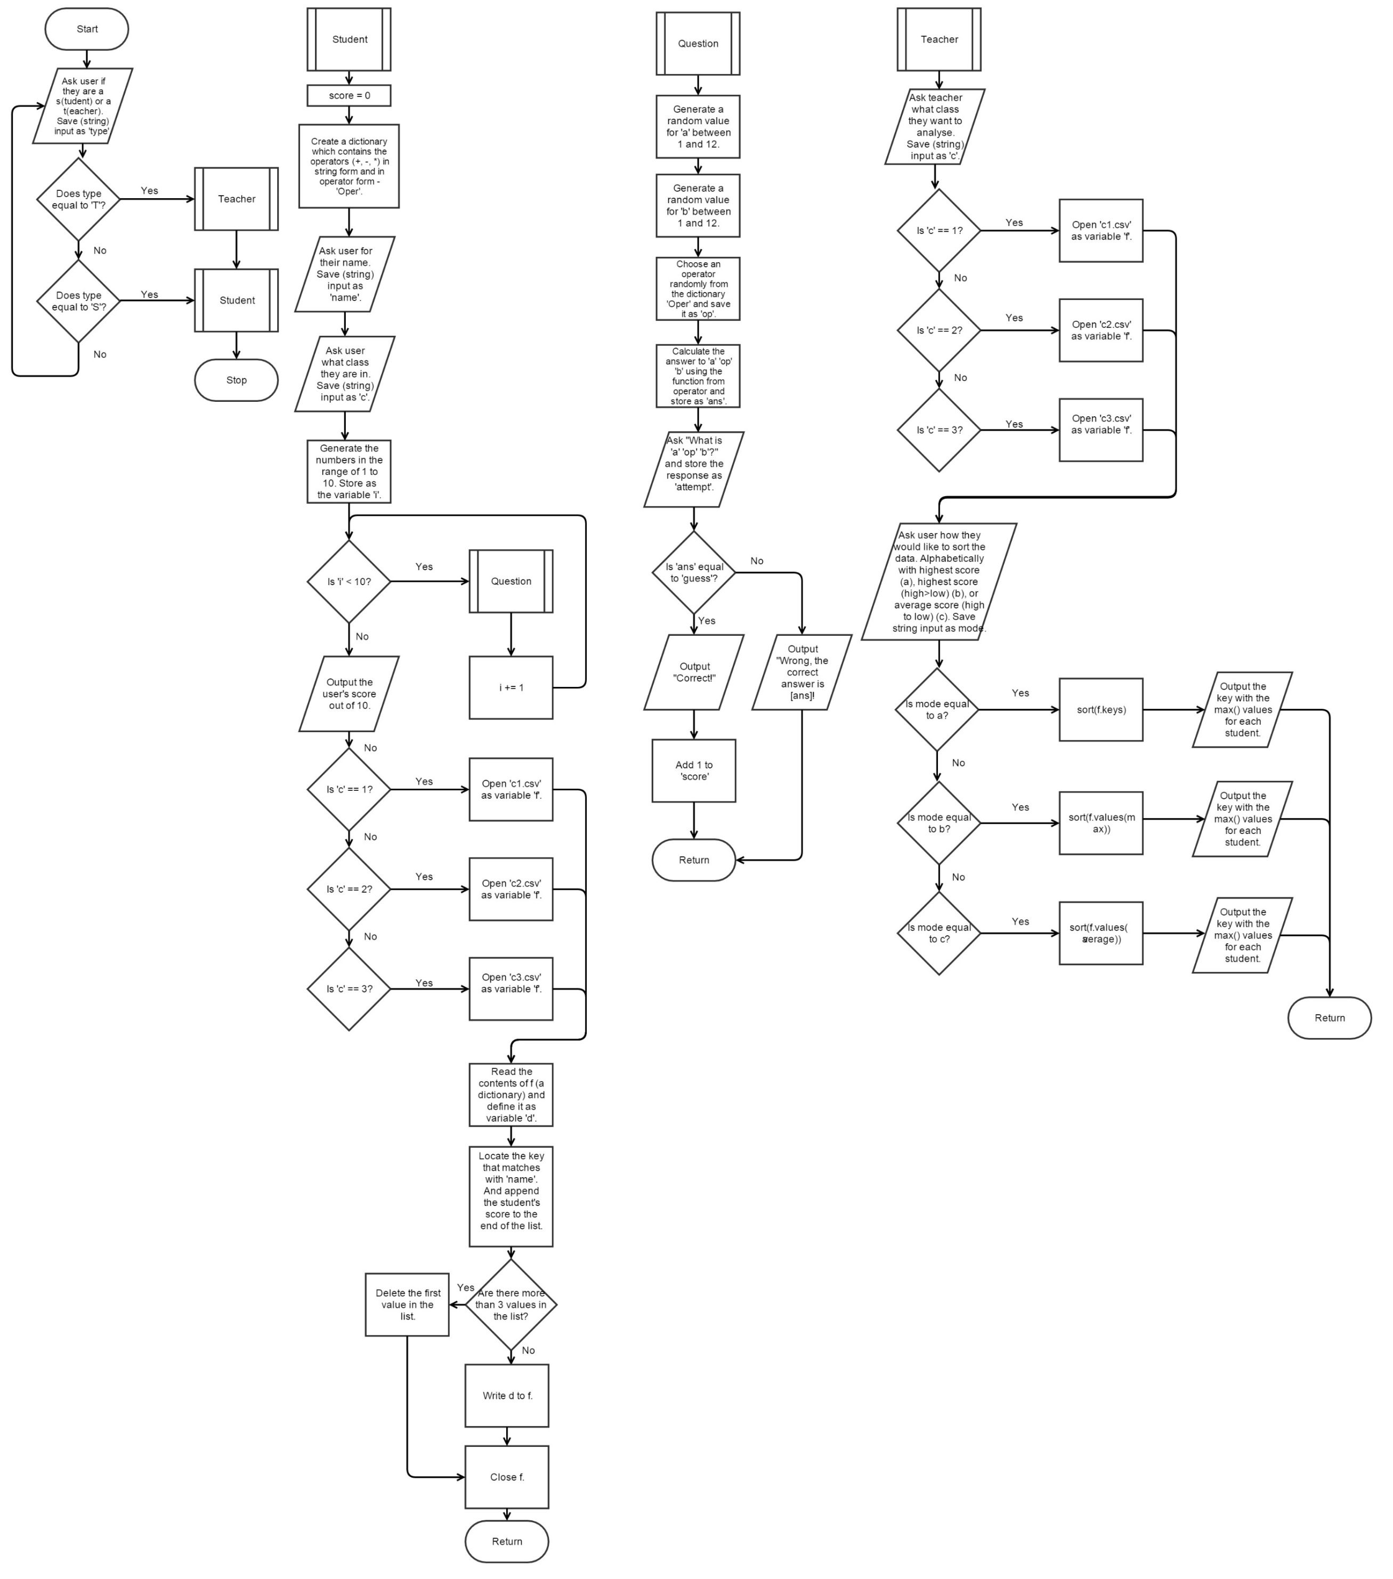

I ran into one issue while creating my algorithm. Gilffy.com did not work successfully on internet explorer thus I had to use Google Chrome instead – as it is more optimised for the HTML5 which the website uses. This problem did not take very long to overcome.

### Version 1

#### Data dictionary

I was able to complete the data dictionary without any issue; I looked over my code and listed all of my variables then, I explained their purpose. However, at the end of the entire task I realised that I had misunderstood what validation meant. I was writing guidelines for my variables rather than the actual validation my code was enforcing. For example, my code did not force ‘name’ to be a string it just needed it to be.

#### Code and test plan

Due to the research which I had conducted, I knew which functions I needed to use for my code. I chose to combine teacher code and student code into one program in order to make the code more of an ‘all-in-one package’. However, this just ended up making the code harder to debug for version 2 as an issue with the student code could cause problems for the teacher code. This possible problem still existed after I had split the code into two parts in version 2 as both programs were using the same data file. If one program causes issues in the data file, the other program consequently cannot work.

When I tested the code, IDLE stated that the syntax was invalid and it highlighted a colon at the beginning of my teacher function. I quickly realised that this was because I was missing two brackets at the end of the line. The line should have looked more like the line in my student function.

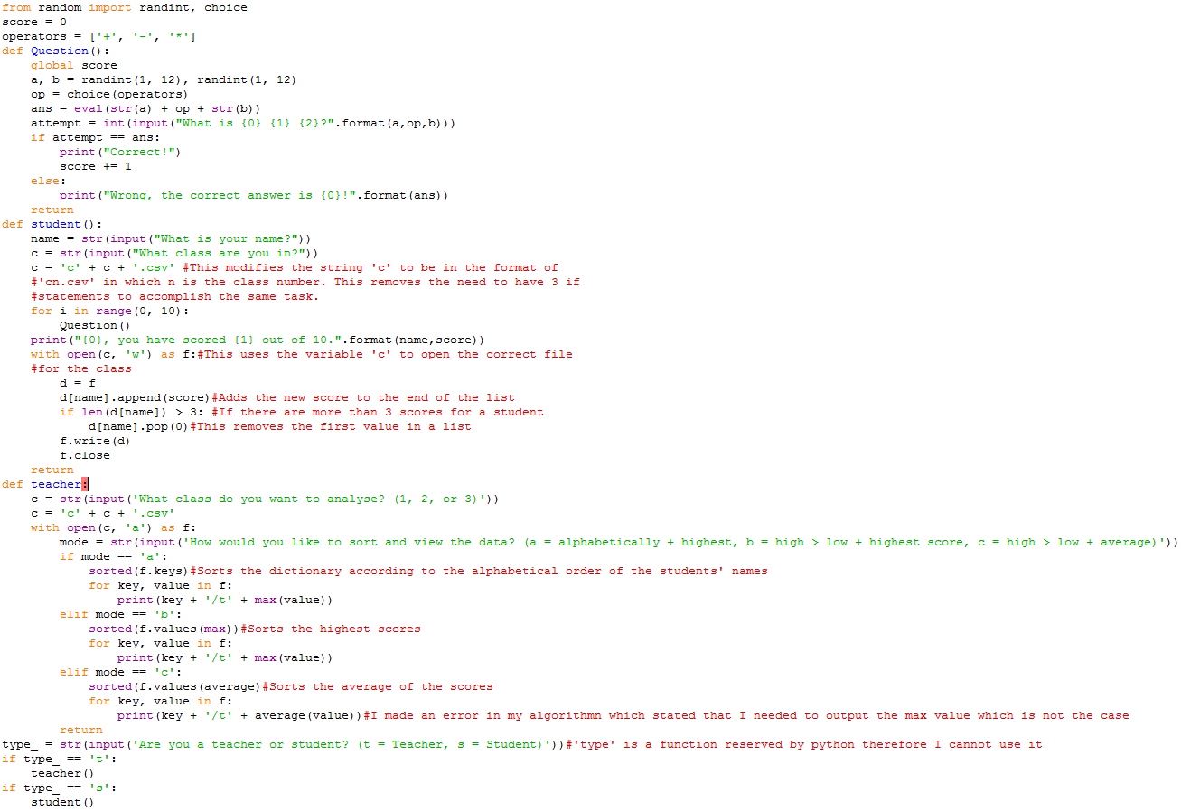

However, I realised that it was meaningless to test and improve my code any further; my understanding of the task’s requirements was wrong. I will elaborate on those in the next evaluation.

### Version 2

There was no authentication for teachers and therefore anyone could claim to be a teacher. By separating the code for teachers and students, I have effectively added another security measure. Students would only ever have access to the student program and teachers would be able to access both programs. The issue of security falls upon the school. Additionally, the combined code is far more difficult to debug as an issue with one aspect of the code could potentially cause unexpected problems to occur. Thus, I chose to separate the code into two parts and planned to combine them in the end. However, due to time constrains I could not attempt this in the end.

I used the research I had already performed in order to amend my code to make it functional. In each test, I tackled a different problem in my code. I will explain these in their evaluations.

#### Data dictionary

Like with my first data dictionary, I was able to complete it without any issue; I looked over my code and listed all of my variables then, I explained their purpose. However, at the end of the entire task I realised that I had misunderstood what validation meant. I was writing guidelines for my variables rather than the actual validation my code was enforcing. For example, my code did not force ‘mode’ to be a string - it just needed it to be. Due to time constrains, I could not ultimately improve my data dictionary.

#### Teacher testing

##### First test

In this test I tackled the first issue I had with my code. I realised, through my research and failures, that dictionaries could not be sorted. Therefore, my method of storing the students’ name alongside their scores, in list form, as key, value pairs (e.g. Manav : [1,2,3]) was incorrect. I understood this by finding a tutorial on how to use the various functions of a dictionary - <http://www.tutorialspoint.com/python/python_dictionary.htm>. Going back over the python documentation for dictionaries (<https://docs.python.org/3/tutorial/datastructures.html>.), I was able to solidify my understanding of this. I overcame this issue by thinking of a new method. My new approach was to store the classes as the keys and the names and scores of the entire class as values i.e. 'teacher1': [['Manav', 8, 10, 9], ['Vraj', 3, 2, 2], ['Parth', 1, 10, 2]].

My first test involved creating a test file by creating a dictionary and attempting to retrieve data from it. I created a sample dictionary (with 3 key and value pairs) and I attempted to retrieve the data for one class. Because my fundamental understanding of python data structures was correct because of the research I had conducted, I was able to do this without any issues.

##### Second test

This test involved me reading a dictionary contained in a text file and isolating the list for 1 class. I did not run into any issues while writing the code but when I executed it, I received an error. Y 

My mistake was that I did not use the eval() function like with my teacher code. My program was originally reading the data and storing it as a string. This made it impossible for me to use dictionary methods like ‘.get’. I was able to fix this in version 2 of this test by using the eval() function to convert the string into a dictionary. As I had already used the function, I had no difficulty incorporating it into my code.

##### Third test

This test was the most difficult of all of them. I did not know how to sort list based on another list and therefore I had to conduct additional research.



This was the most useful resource for me as it explained the solution in addition to providing an example. From that, I understood that a lambda is a function that exists temporarily. This allowed me to it for every mode of sorting. For mode a, I sorted the entire list in the alphabetical order of the first item – the name. I then used a for loop to iterate through the class list. For every item in the list (each individual sub-list) it output the name and highest score – which I did with the max function. For mode b, I sorted the entire list in the numerical order of the largest score – using the max function. I then used a for loop to iterate through the class list. For every item in the list it output the name and highest score. For mode c, used a for loop to iterate through the class list. The loop averaged items 1, 2 and 3 in the sub-list and appended it onto the sub-list after deleting all of the original scores. For every item in the list (each individual sub-list) it output the name and average score. Deleting the scores was not a concern as it was only reading from the data file, my code was not outputting anything to the data file.

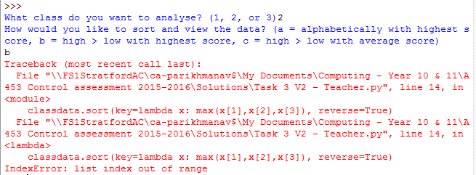

When I tested this, I my code had a bug, when testing mode b; mode a, however, was working. My code was reading data from items 1, 2, and 3 in a sub-list. Subsequently, if a sub-list did not contain 3 scores, the list index is out of range. I attempted to debug this when I coded my

##### Teacher Code



In the previous test, I had essentially written all of my code for this task. However, I need to fix the issue that arose. I used if statements in order to verify how many items the sub-list contained when my for loop iterated over them. Then, I used a different argument for the ‘.sort’ method to ensure that the index was within the range. However, I ran into an issue when I tested my code.



I did not know how to overcome this issue as the problem was fundamentally different to the prior issue. I could use if statements to verify

#### Student testing

##### First test

The first issue with my code was my confusion in the lists and dictionaries I had used. Firstly, my code was reading the contents of the data file as a string rather than a dictionary. Having done the teacher code, I now knew that I needed to use the eval() function in order to convert the string into a dictionary. Secondly, I was storing each student’s data as a separate entry in my dictionary. This was a wrong choice as data in a dictionary cannot be sorted. With that in mind, I have conducted some tests in order to ensure that I can do version 2 of my student code correctly.

In this test, my program output my message because ‘Manav’ was in the class list.

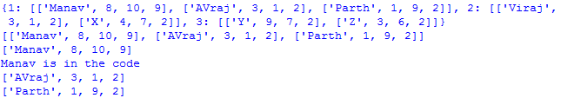

##### Second test

This second test simply adds a (dummy) score onto a person’s list if it already exists. If the student has more than 3 scores then their oldest score is deleted. Additionally, if the student’s name is not in the list, a new list is created for the student.

In test number 1, the program recognised that Parth has a sub-list and consequently it appended ‘score’ to it. Additionally, it did not remove any of his scores as his total number of scores did not exceed 3.

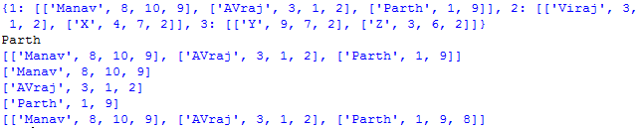

In test number 2, the program recognised that AVraj’s sub-list has exceeded the threshold of 4 items thus it should remove his first (oldest). 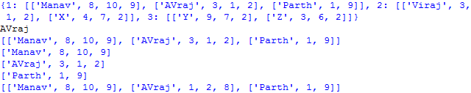

In test number 3, the program recognised that no sub-list existed for ‘Newcomer’ and therefore it created one.

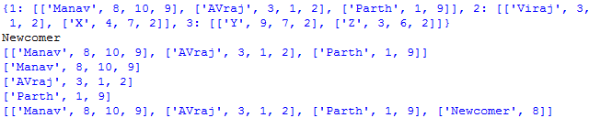

Having conducted this test, I know how to add a score onto a person’s list if it already exists; delete the oldest score if there are more than 3; create a new list for a new student.

##### Third test (all versions)

So far, I have been creating new variables to modify the lists. For this test, I needed to write the modified data to the data file. This was the final test which I needed to conduct before I created the student code.

Test number 1 was conducted in order to check if the updated dictionary ‘a’ was output to the data file: AVraj’s scores should have changed from [3,1,2] to [1,2,8].

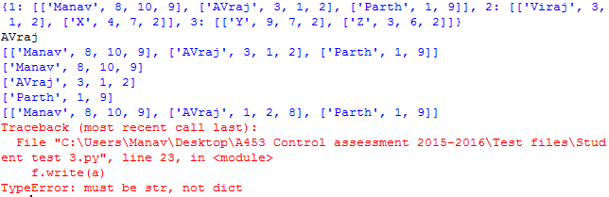

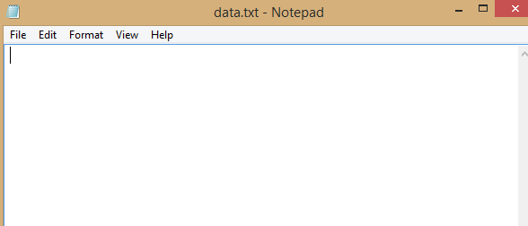

The contents of my data file were erased because of the ‘w’ argument I had used in my open() function. This is one risk of using the this line of code, however, if I ensure that my final code does not have any errors which cause this and I keep regular backups of my data file during development, this should not be much of a problem. I did keep a copy before I conducted this test thus I can easily restore the file. The variable ‘a’ was a dictionary and therefore it could not be output to the data file. In order to overcome this, I simply converted it into a string before it was output in the new version.

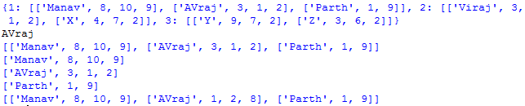



The shell did not give me error messages but my text file was still deleted. I think that this was because f was being unassigned. I planned to remedy this in the next version by using the same measure that I had used for reading the file. I also placed the write function on the same line that I have the open() function on.



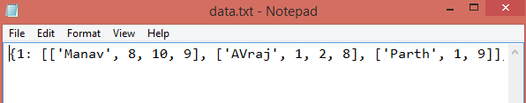i

Through repeated debugging, I was able to overcome the issues I faced in this task.

##### Student Code



Having conducted the tests, I felt confident doing the code. If I had not conducted my three tests, I would have faced the issues I faced in the third test now. Consequently, I did not run into any errors when testing my code.

In test number 1, the program asked a student 10 random questions. This met one of the success criteria for the task.

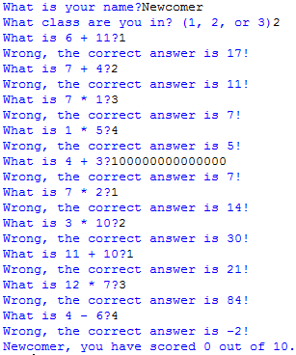

In test number 2, I checked the number of scores which were recorded per student. My data file only had up to 3 scores in each student’s sub-list. This met another one of the success criteria

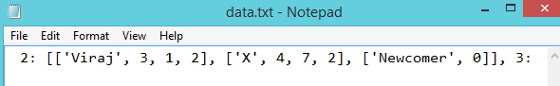

In test number 3, the program read Newcomer’s sub-list and append the new score onto it.



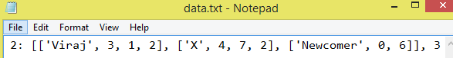

Ultimately, I could not attempt version 3 as I was nearing the 20 hour limit for the controlled assessment. However, as my code is still mostly functional, I do not believe that is a large concern. I have met the requirements of the task.